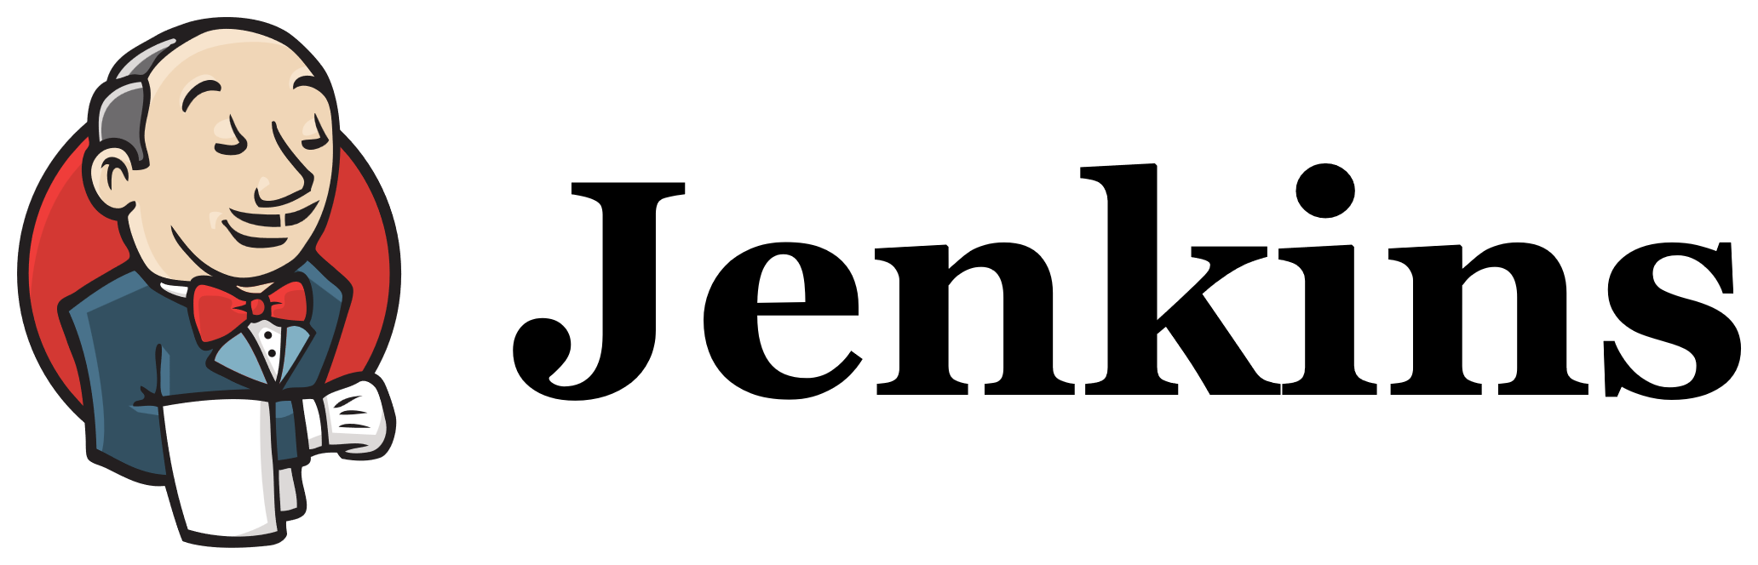
Title:
- Setup Jenkins CICD pipeline using freestyle job using Docker containers using below code. https://github.com/betawins/hiring-app.git Stages:
Git Clone
SonarQube Integration
Maven Compilation
Nexus Artifactory
Slack Notification
Deploy On tomcat
Step 1:
Login back into jenkins
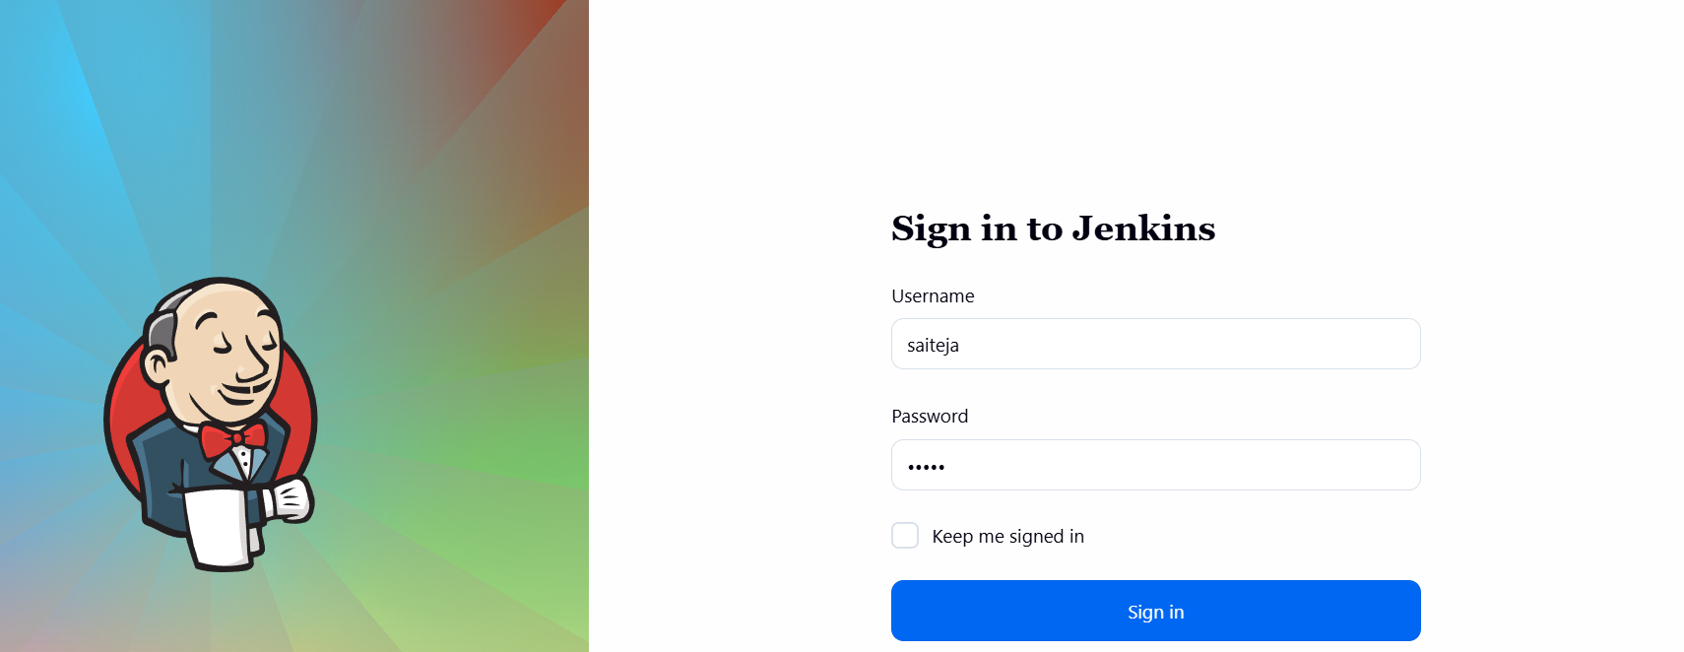
Run the sonarqube which already installed using docker in ec2
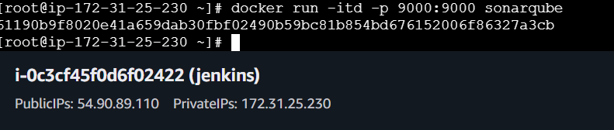

In the website the sonarqube page will be displayed
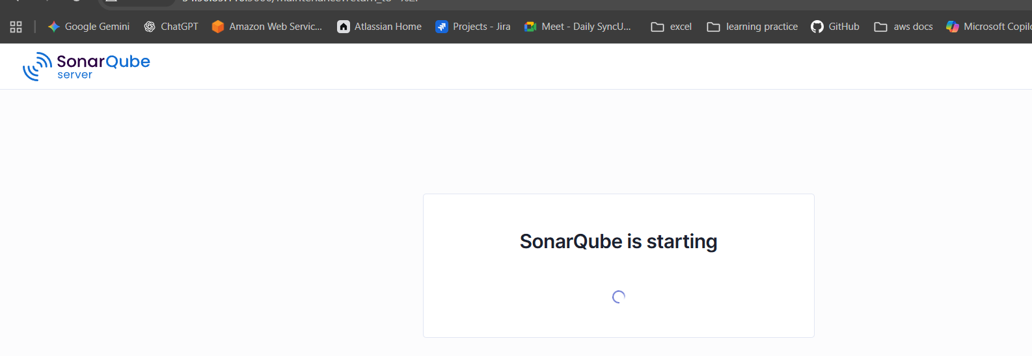
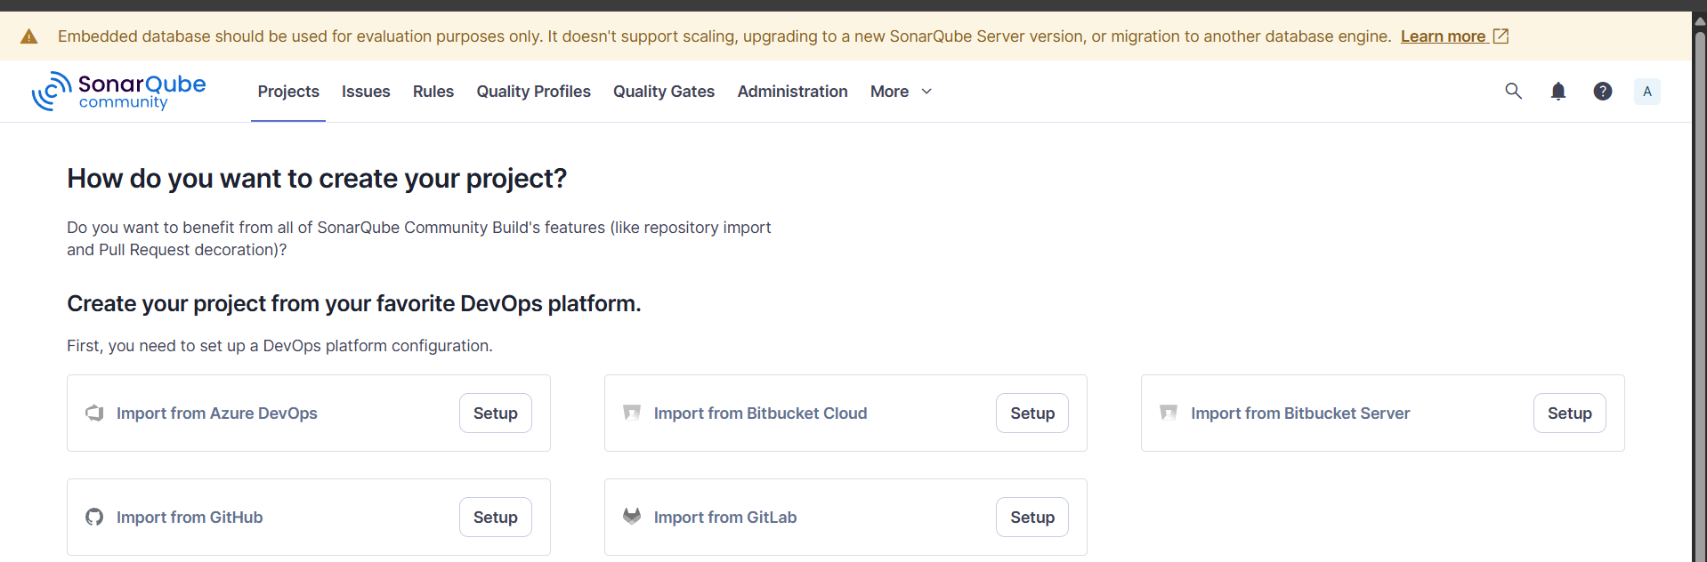
Click on Settings and generate a token for the reason we stopped and started the ec2 so that we need to integrate with Jenkins again and create a credential in jenkins
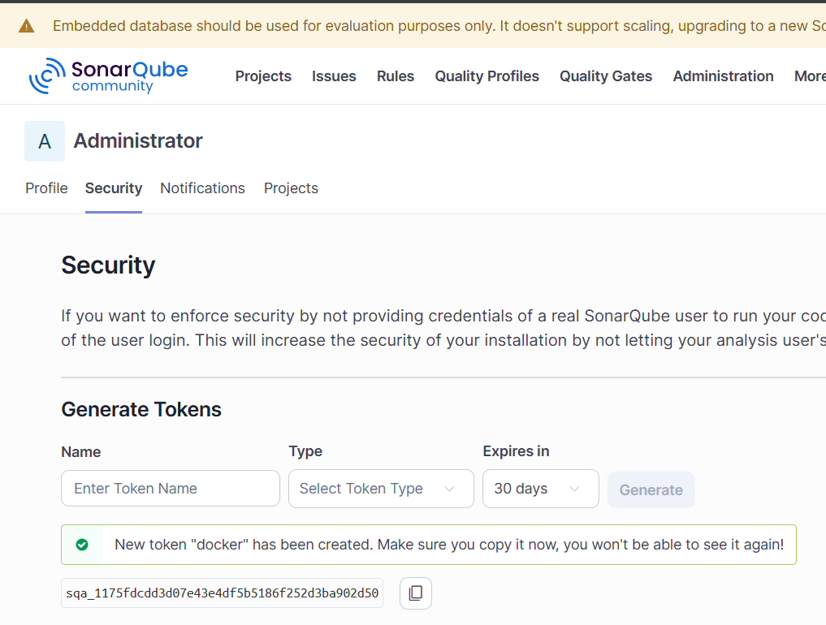
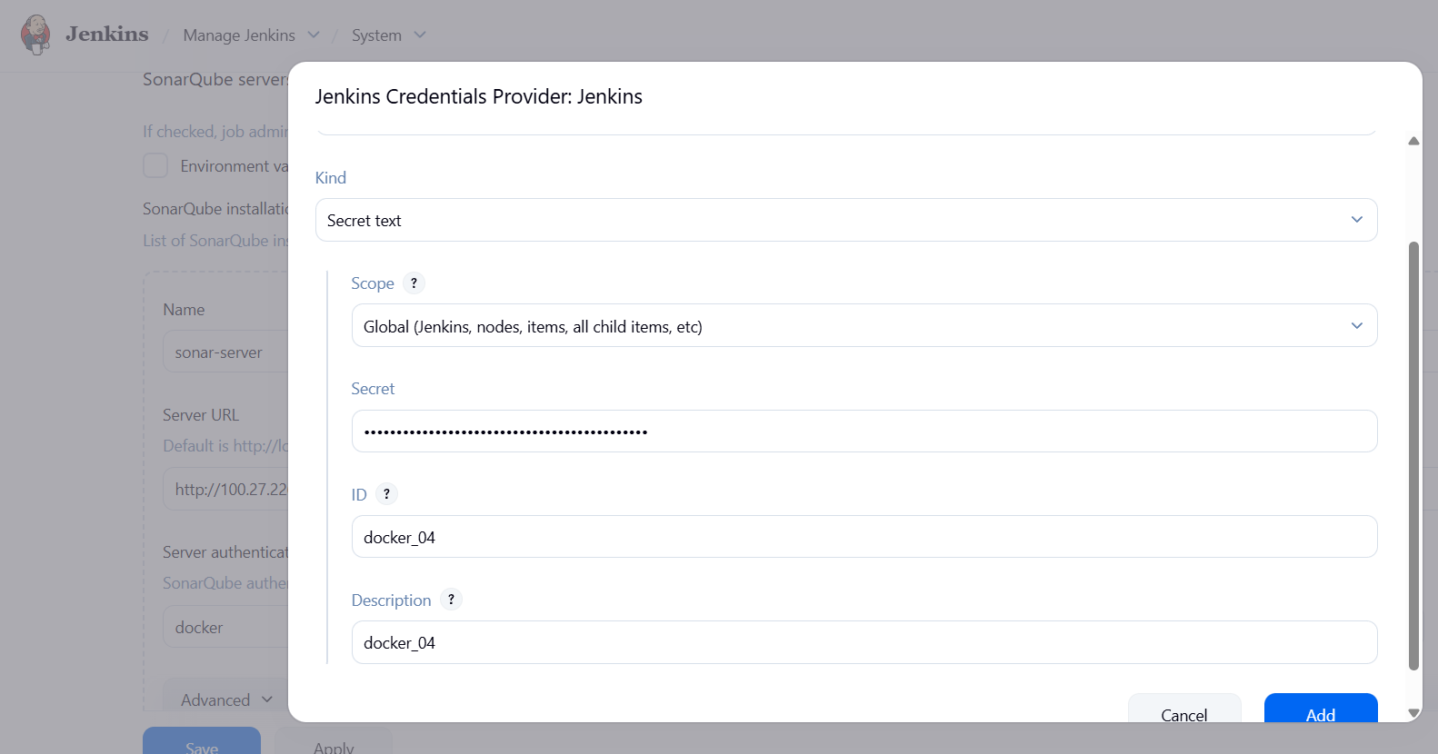
Also change the PUBLIC IP of sonarqube
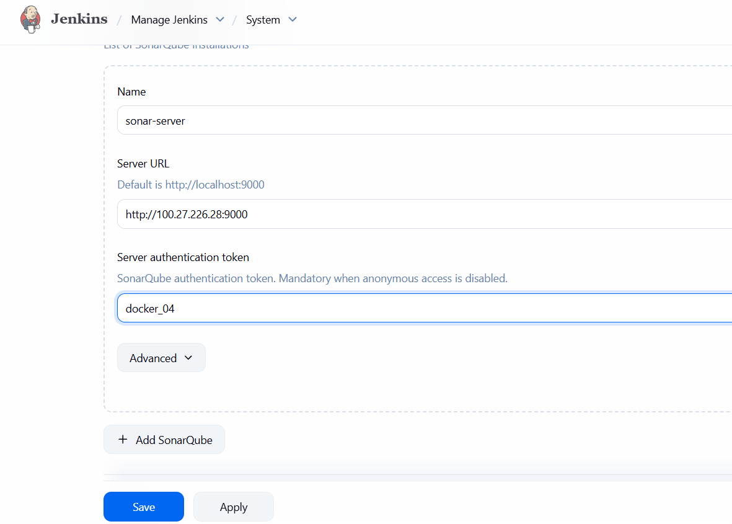

Create a JOB USING FREESTYLE PROJECT
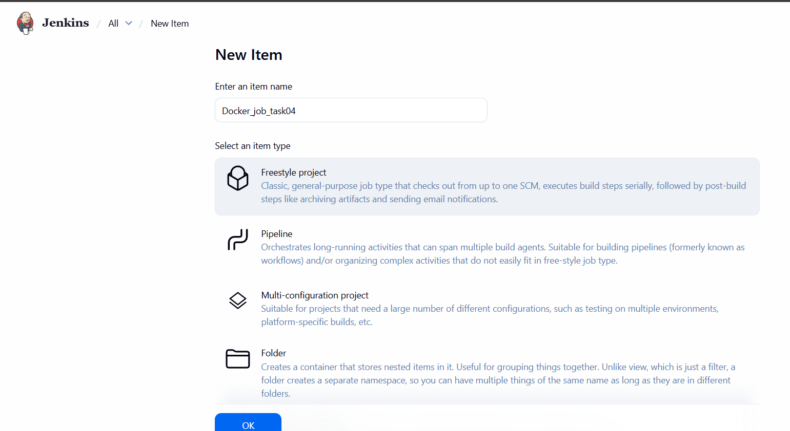
Paste the GIT REPO mentioned in task
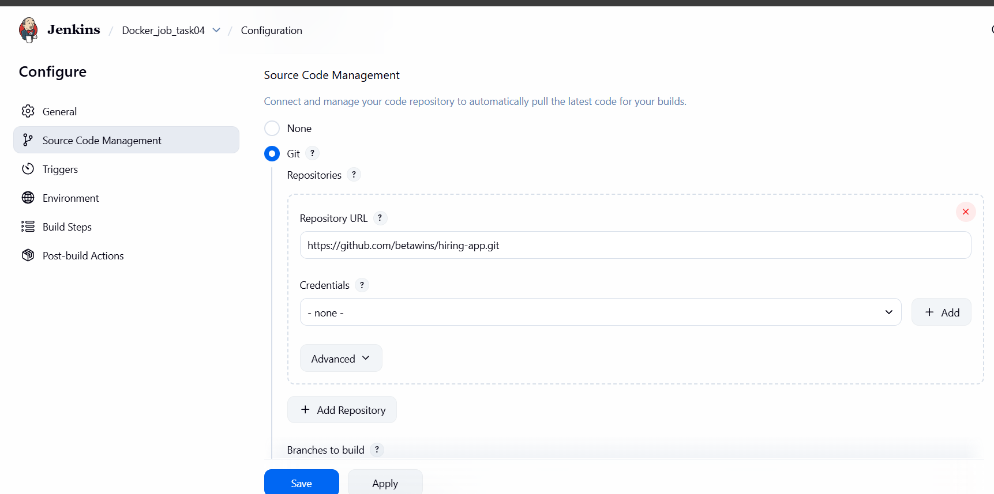

After changing everything it will look like below picture
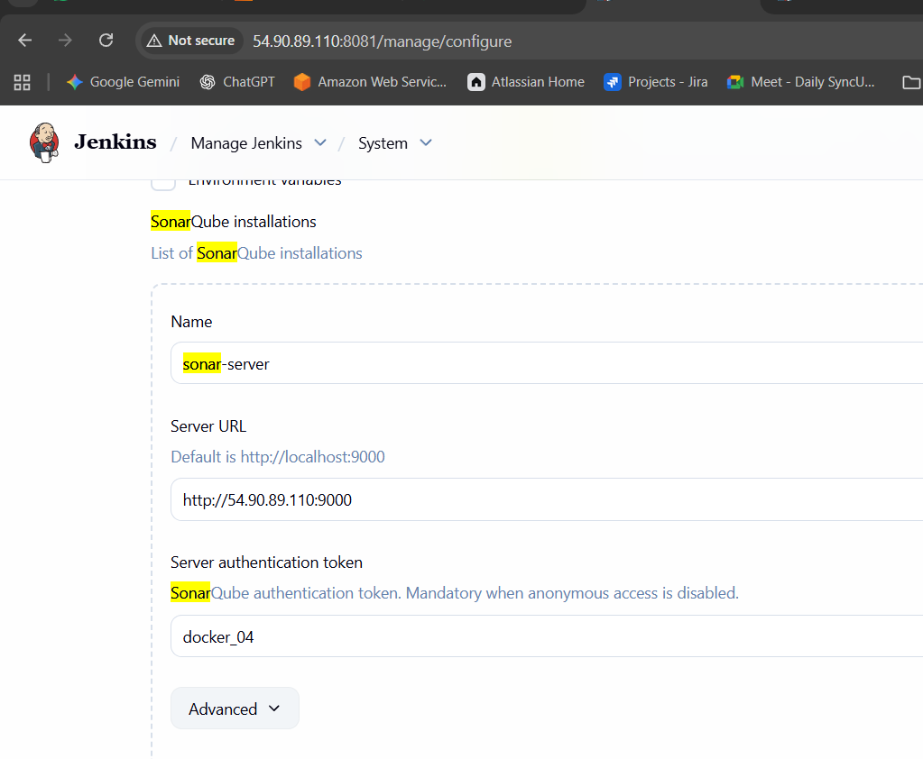

In the analysis properties paste the details which available in GIT REPO
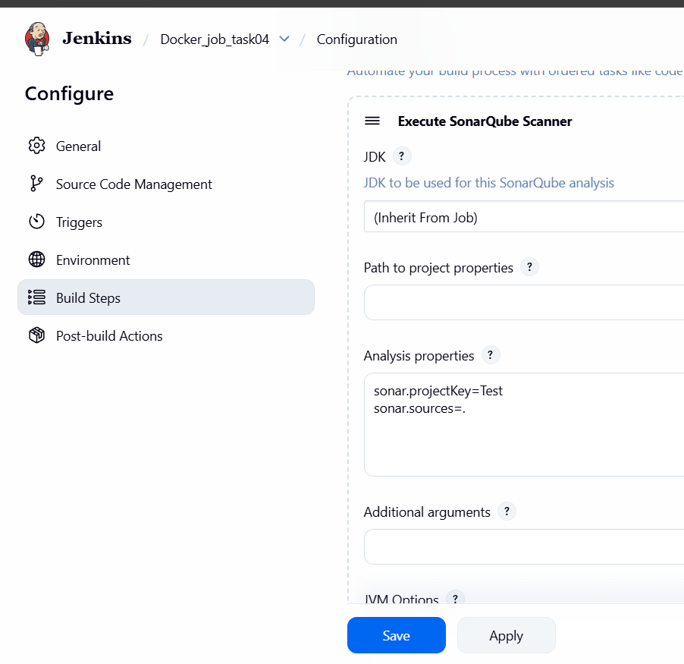
IF YOU FACE ANY ISSUES REGARDING SONARQUBE THEN PASTE THE BELOW COMMANDS IN EXECUTE SHELL IN JENKINS
/opt/sonar_scanner/bin/sonar-scanner \
-Dsonar.host.url=PUBLICIP:PORTNUMBER \
-Dsonar.login=<your-new-token> \
-Dsonar.projectKey=Sabear \
-Dsonar.sources=src \
-Dsonar.java.binaries=target/classes

Sonarqube is ready and will check by clicking on build
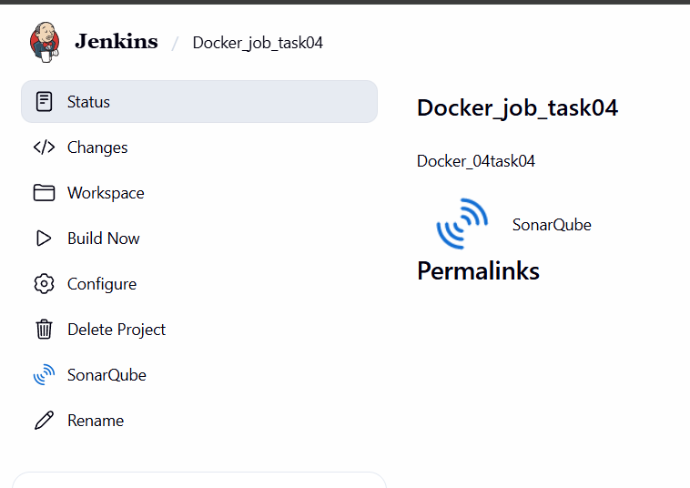
But here I faced an isuue or error and it regarding an branch
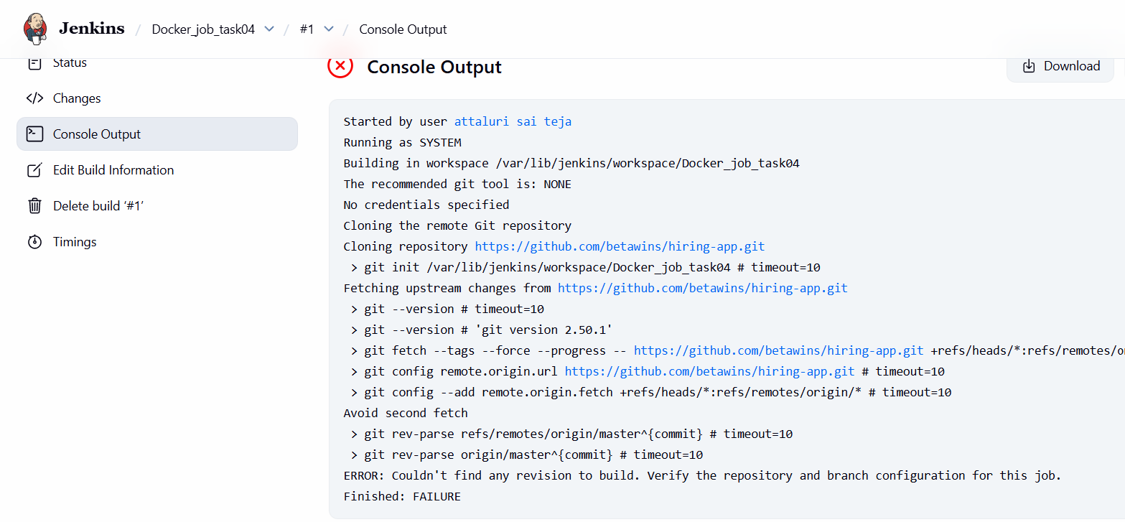

Change the branch to main from master
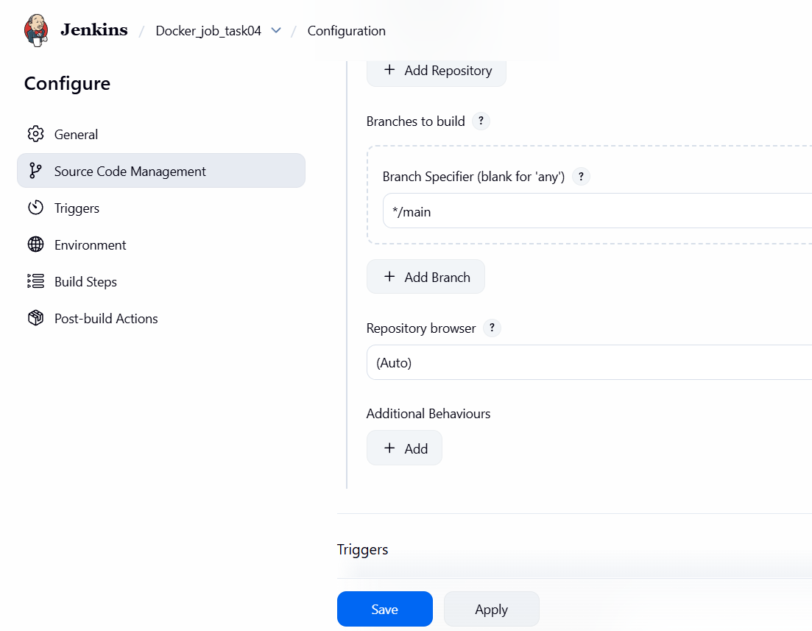
After that the console output is TRUE or success
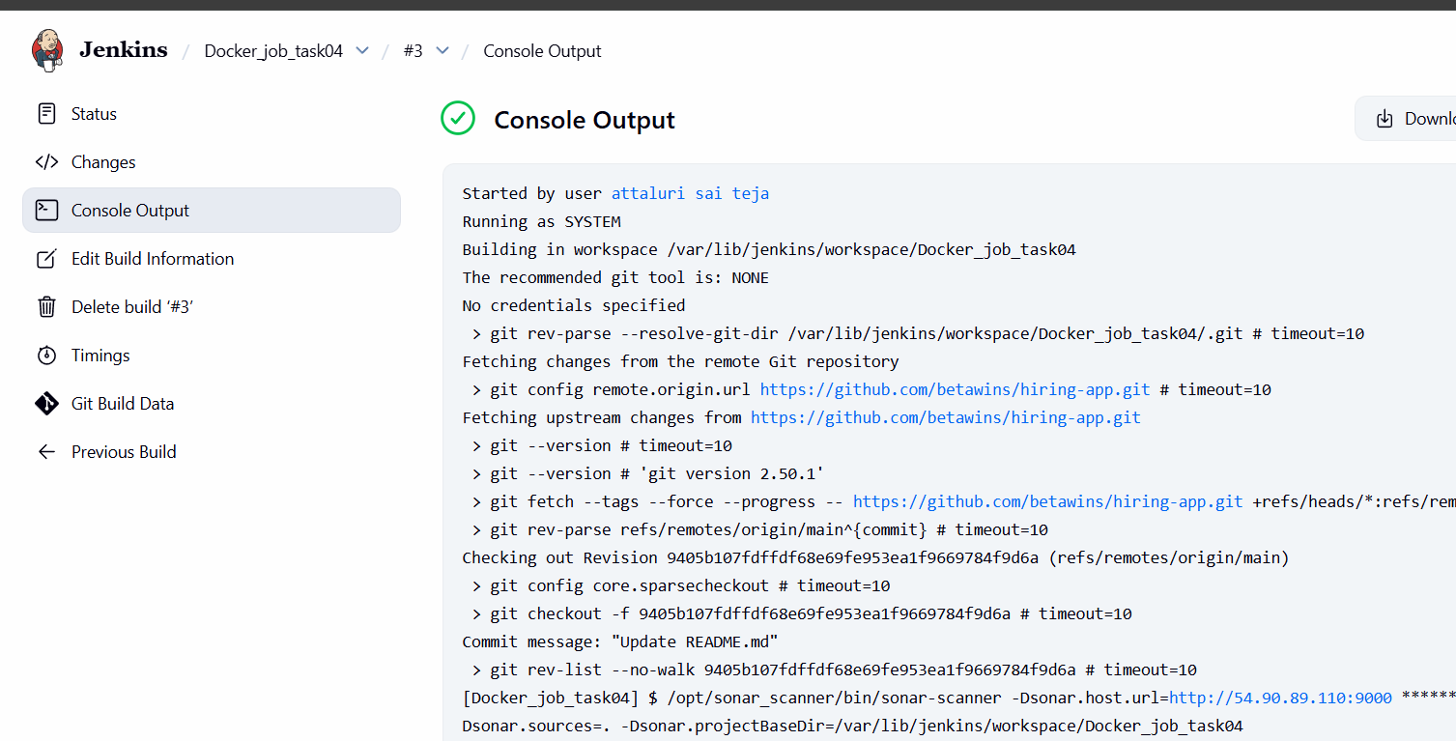

In Sonarqube Server also verified the BUILD
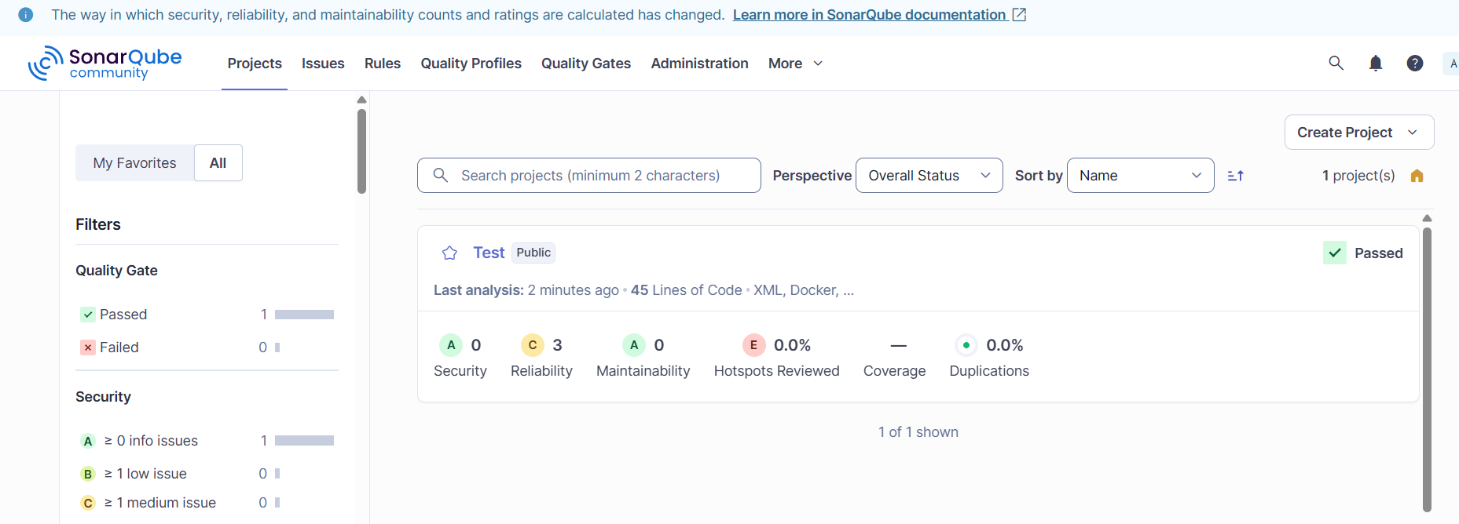
Maven Compilation
Visit official maven website and copy the tar.gz link and paste it over in ec2 in opt location
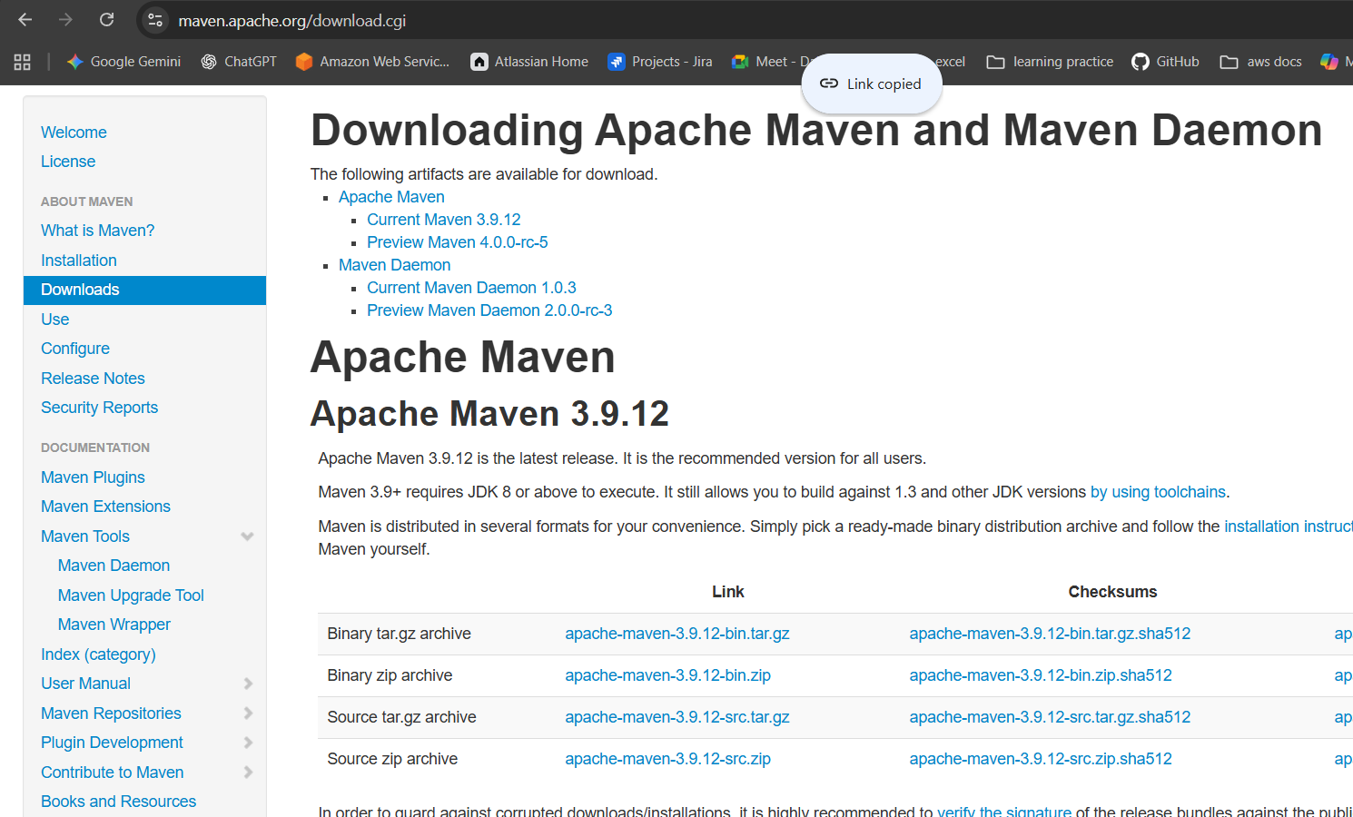
After getting the files use tar command to extract them
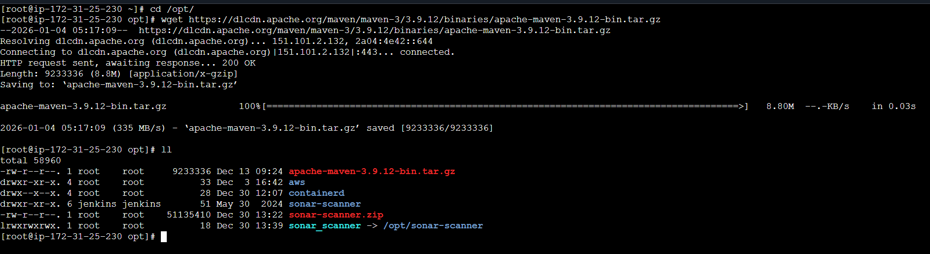

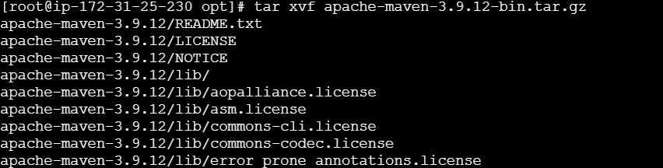
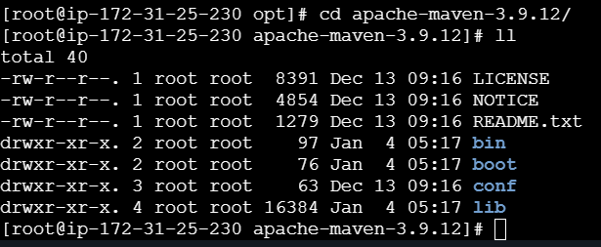
Listed the files and MVN file is displayed
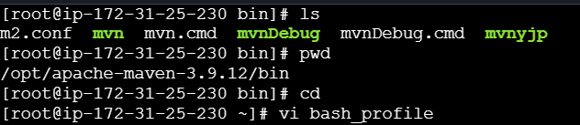

OPEN vi .bash_profile
And paste below commands by that we can check the mvn availability form ec2 not through a bin location
# Define Maven Home (Point to the installation directory, not /bin)
export M2_HOME=/opt/apache-maven-3.9.12

# Update PATH to include Maven's bin and your local bin
export PATH=$PATH:$HOME/bin:$M2_HOME/bin

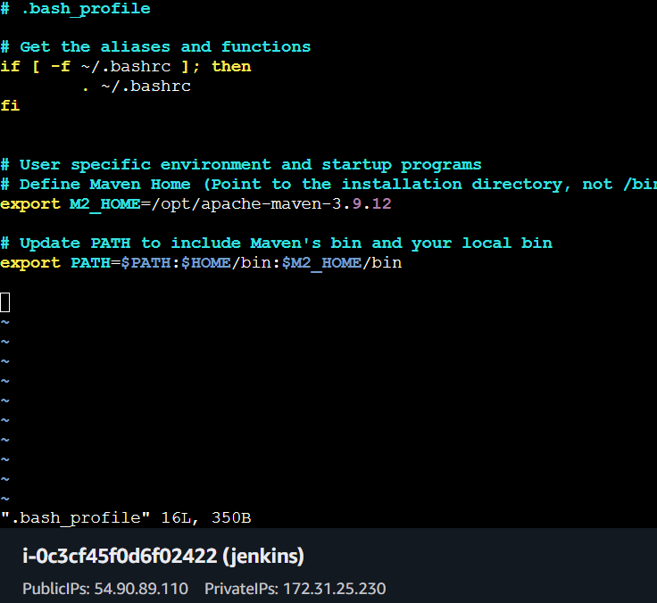
And also refresh the file using source ~/ .bash_profile
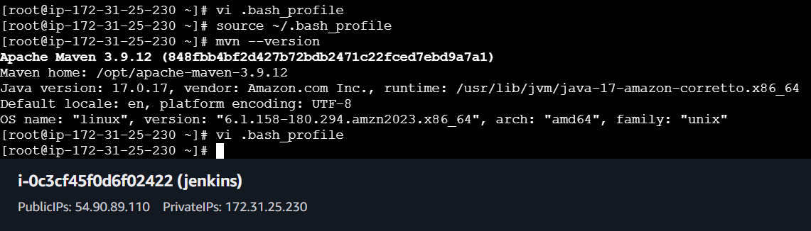
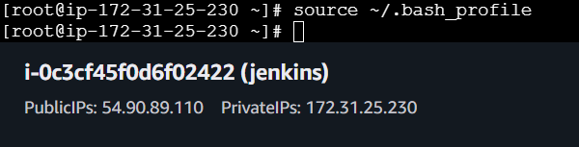

After completing the setup at ec2 level now we need to setup at GUI Jenkins level
Download the plugin called MAVEN INTEGRATION and continue by installing it
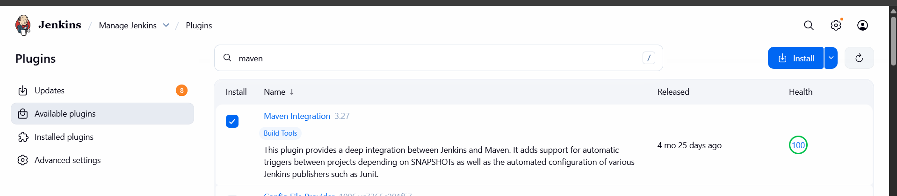
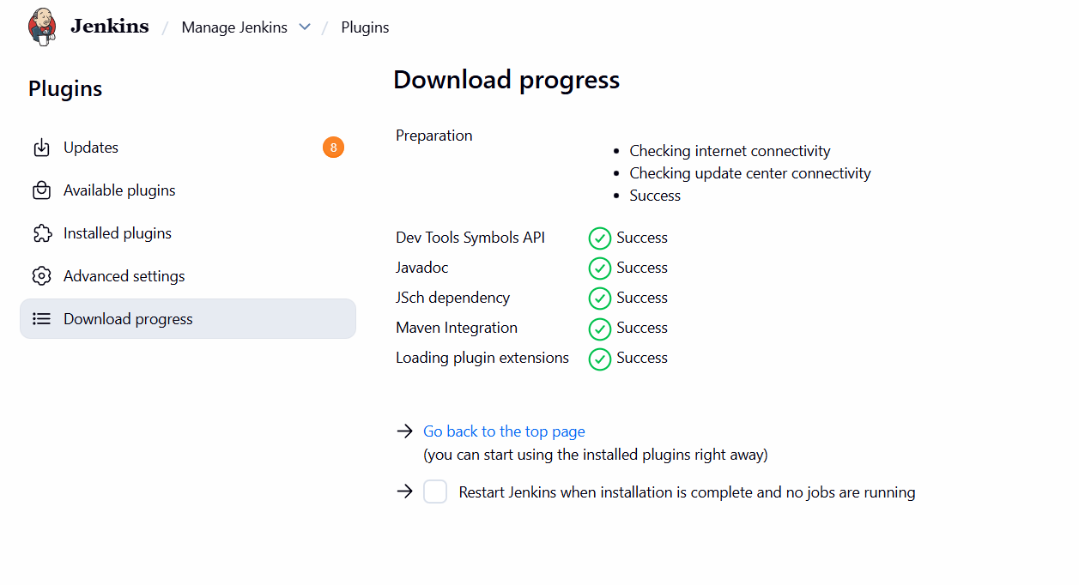

Click on manage Jenkins and select tools and insert data in it
Add the same details which we mentioned in ec2 in .bash_profile
In the maven_home tab mention /opt/apache-maven-3.9.12
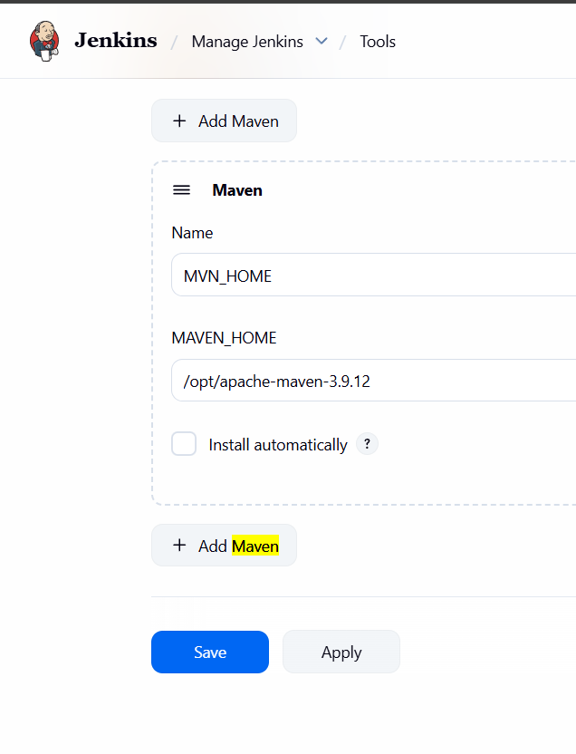

In job Configuration Select Invoke top level maven targets in BUILD Steps
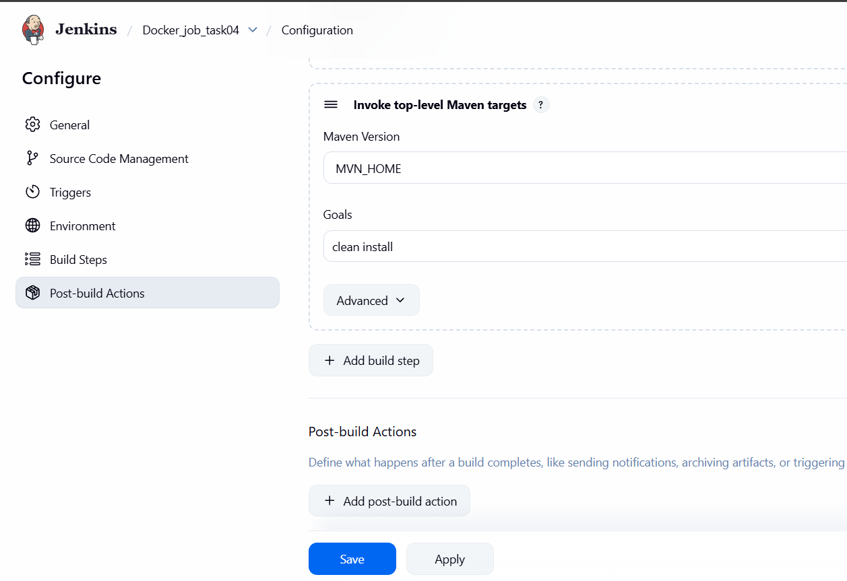
After saving it again tested with clicking on BUILD
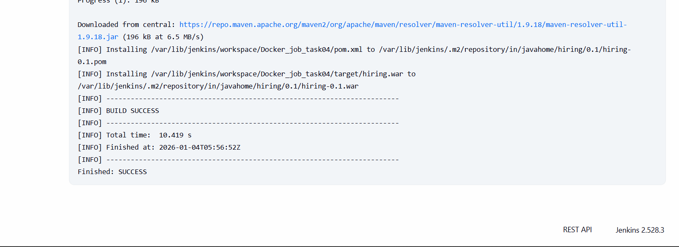
After maven integration a TARGET file will be crated in job in ec2 jenkins also verify that
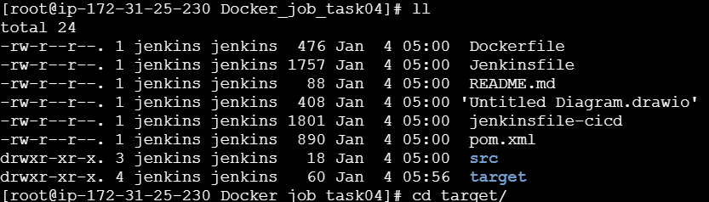
The target file contains war files
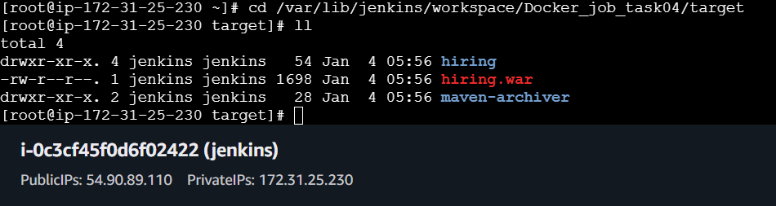
Also a hidden file is created (( .m2 )) in side it a repository is created and it contains all
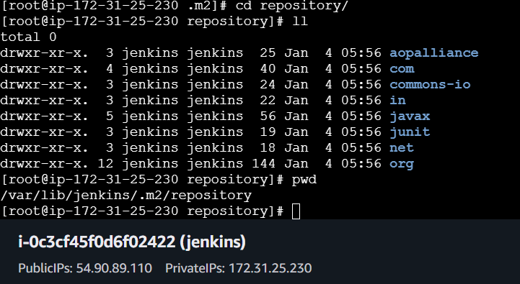

Nexus Artifactory
For nexus arti factory launch an instance and integrate with Jenkins
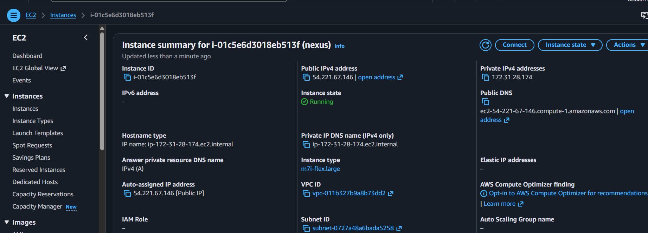

Update the dependencies and wget the link from official nexus website in the CD /OPT location
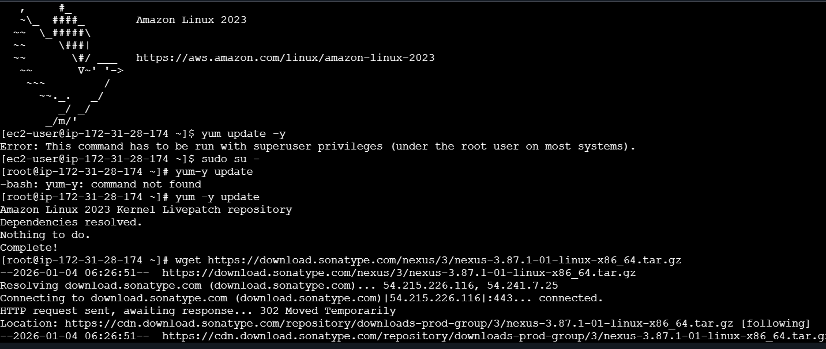
Changed the nexus -3.8.5441 to nexus using mv command
And extract the file using tar
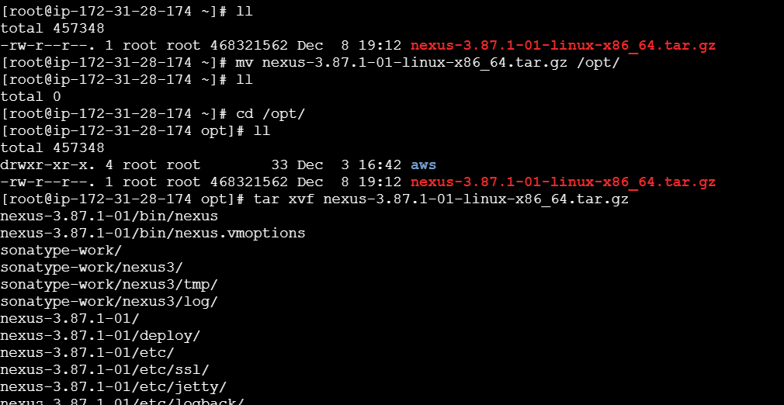

Changed the directory to bin and started the service
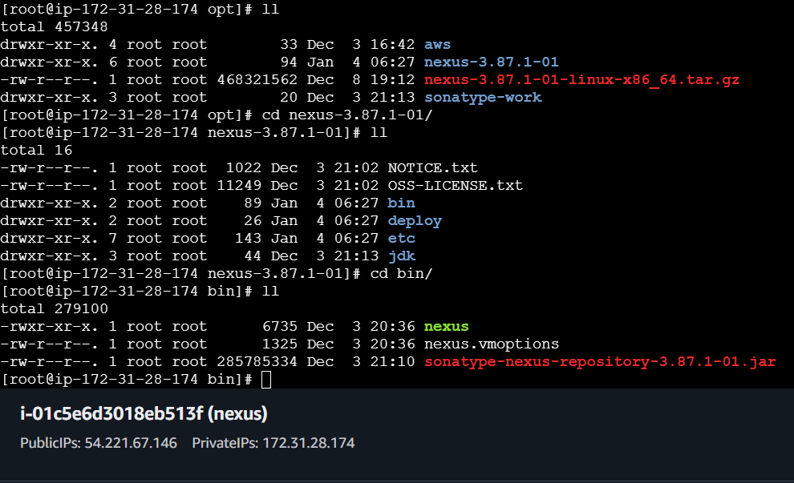command ./nexus start will start the service
If you didn’t get any output in terminal while checking the status then once verify in browser by publicip :port number
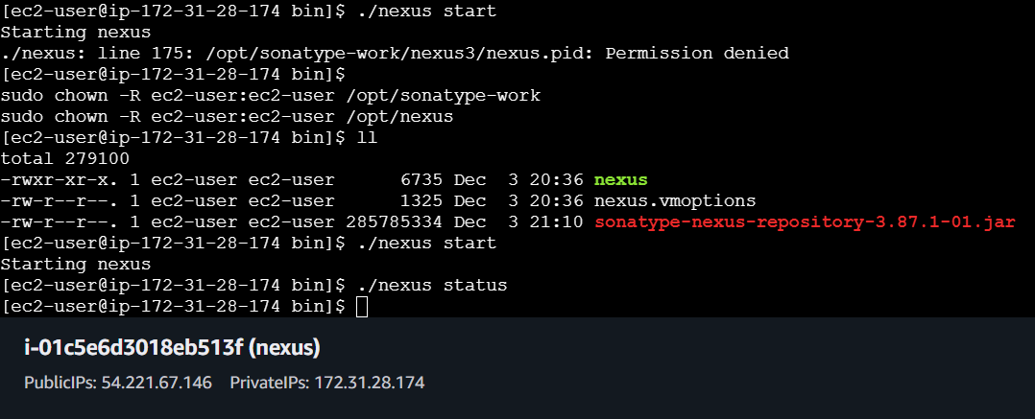

Change the ownership of these files
sudo chown -R ec2-user:ec2-user /opt/sonatype-work and nexus
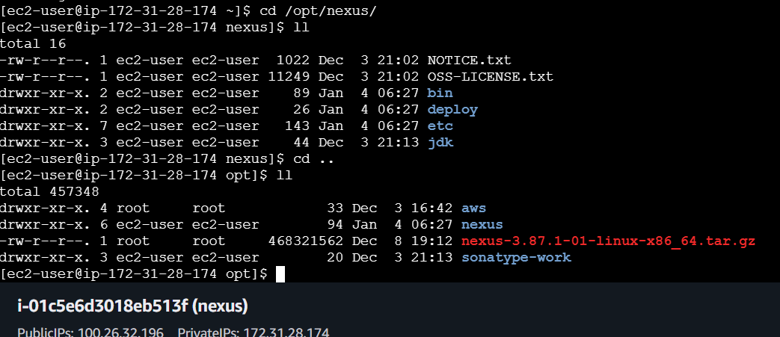
The default username is admin and password is available at
/opt/sonatype-work/nexus3/admin.password just copy and paste it
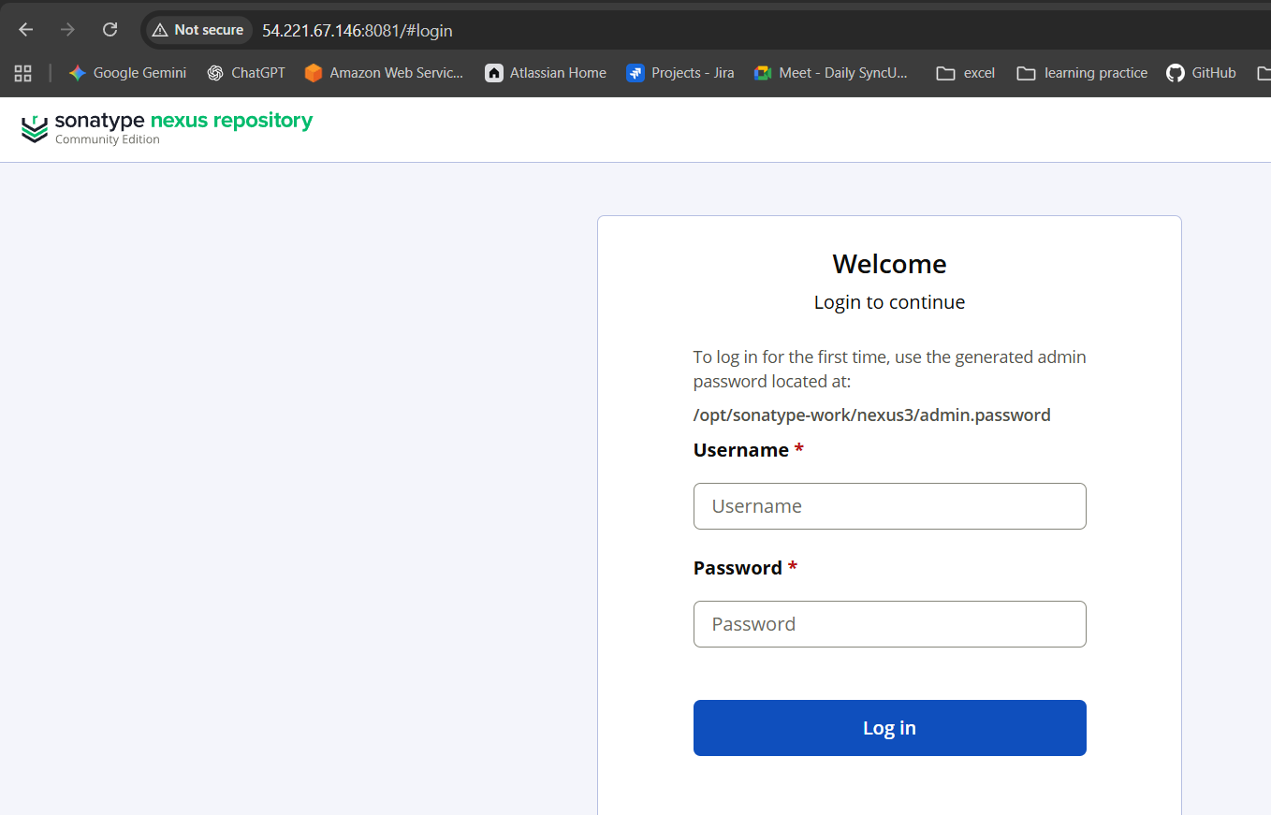
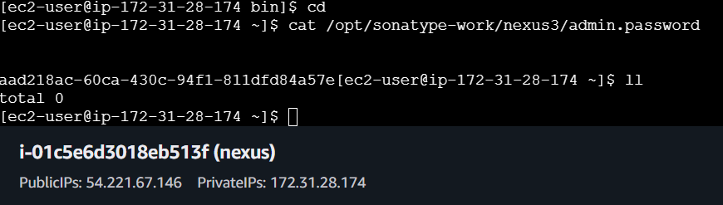
After that change your password after that you will be redirected to nexus dashboard
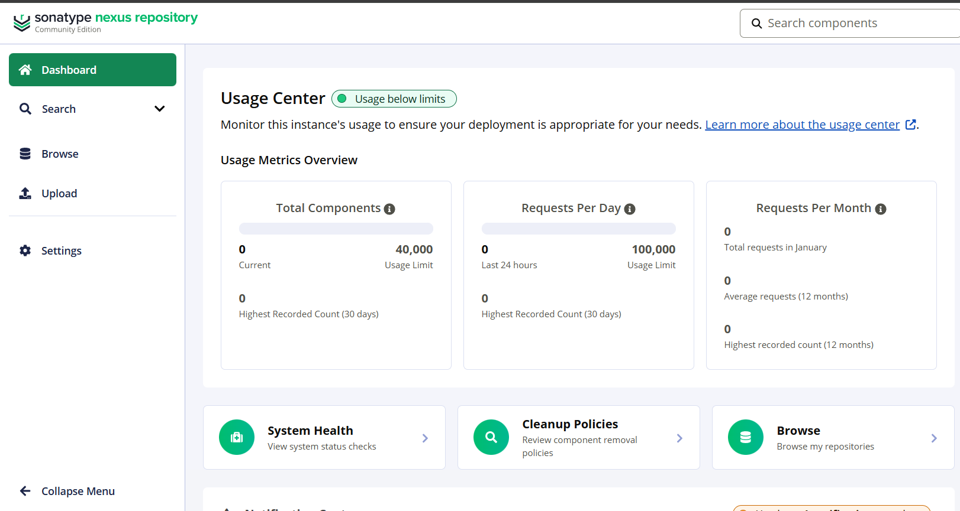
After that again goto Jenkins and install plugin for nexus that is nexus artifact uploader and continue with installation
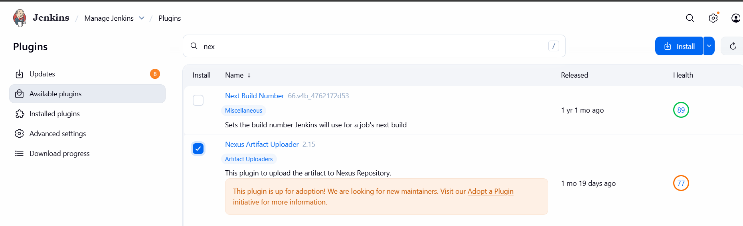
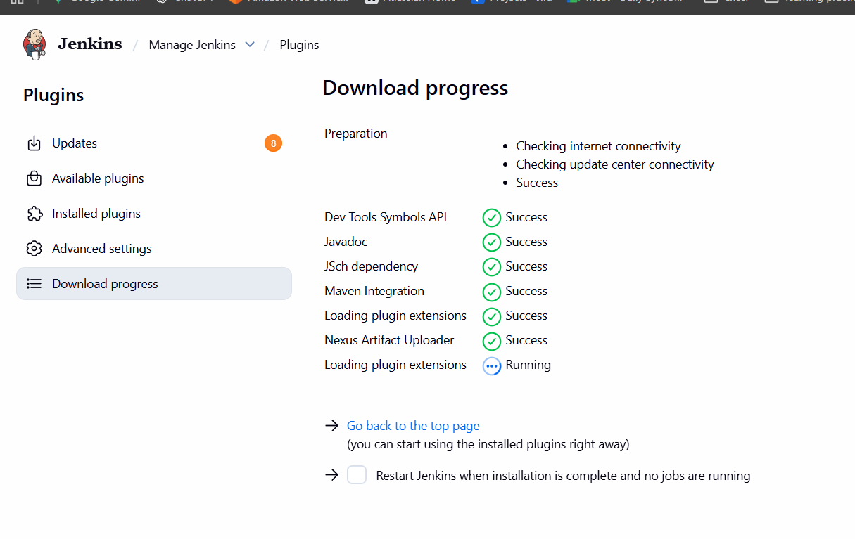
NOTE::: If needed then only restart the JENKINS
In directly job configuration select BUILD STEPS and select nexus artifacts uploaded and enter the details select the version as NEXUS3 and url of nexus
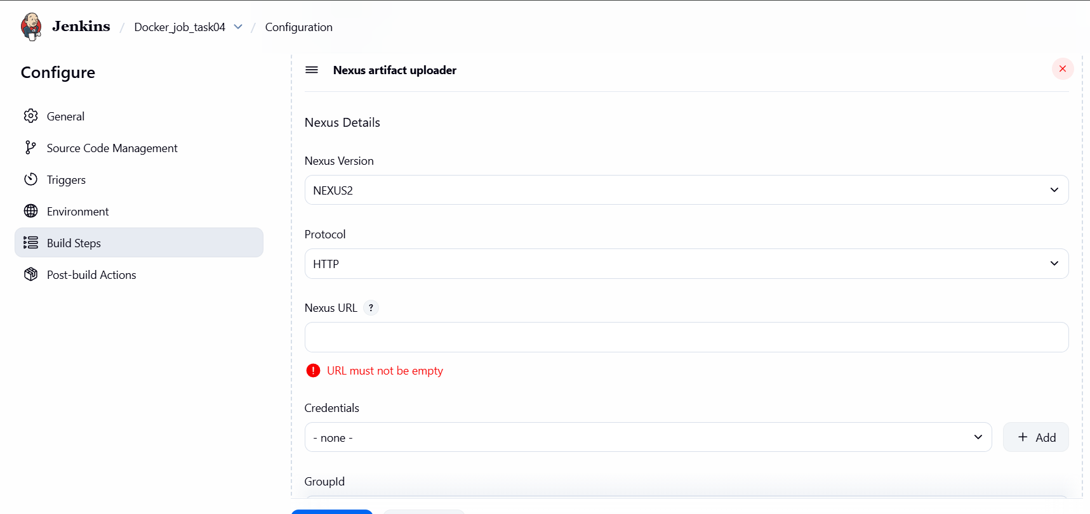

In the credentials the username is admin and password is your nexus server login password
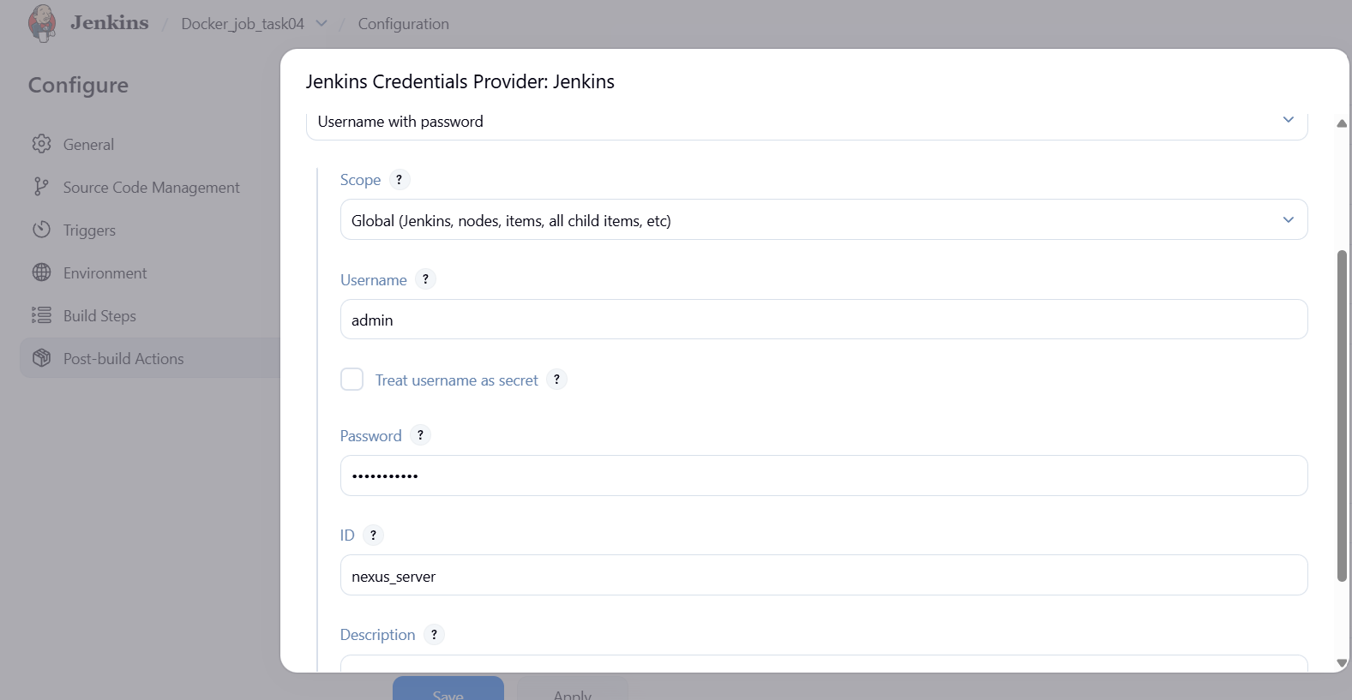
To add the another details like version , group id all will be available in POM.XML file in REPo
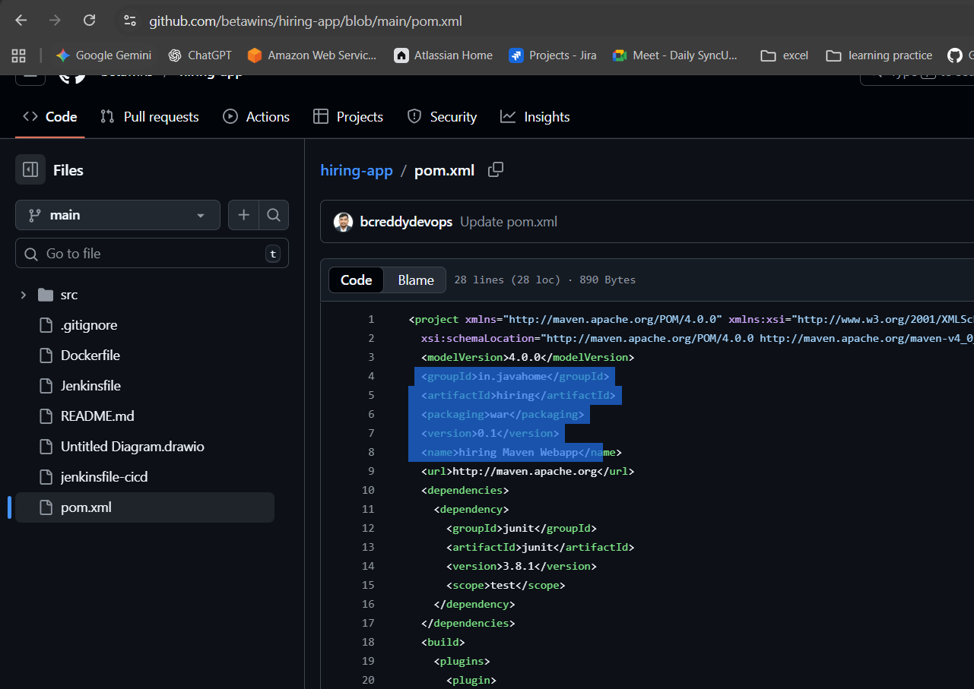
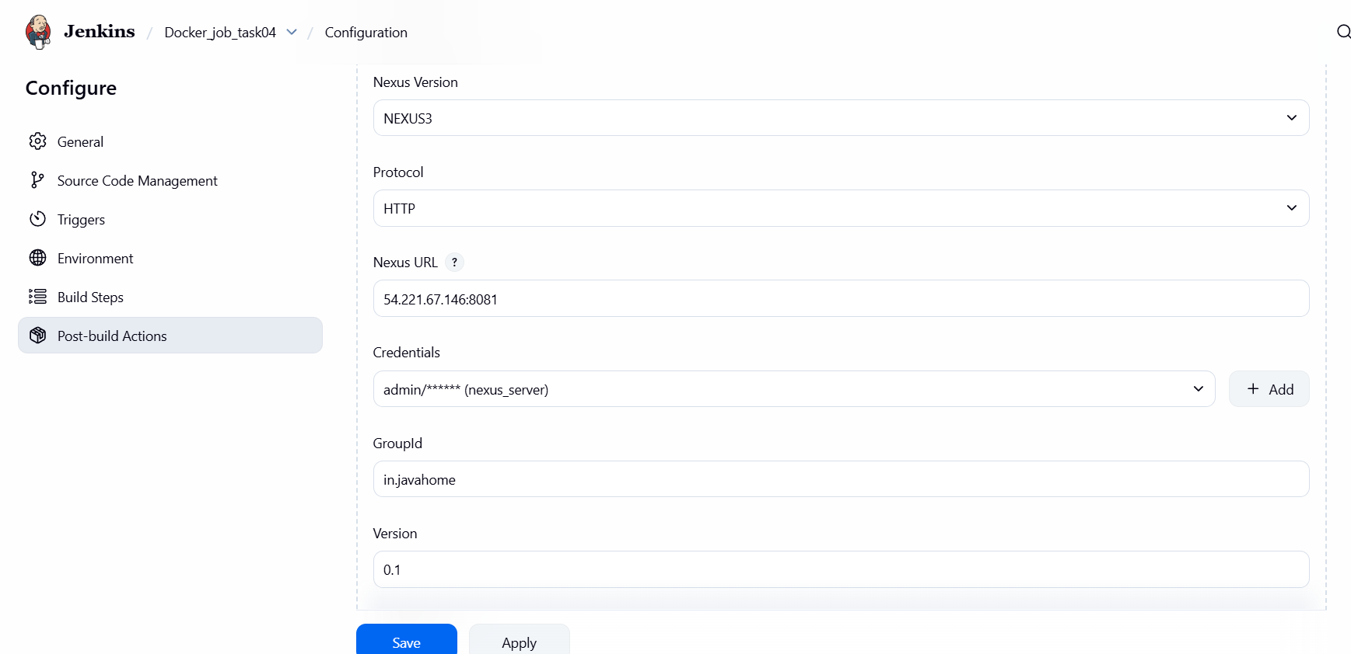
For the Repo name
U need to create a repo in nexus sever for that click on settings and select repository and click on create new
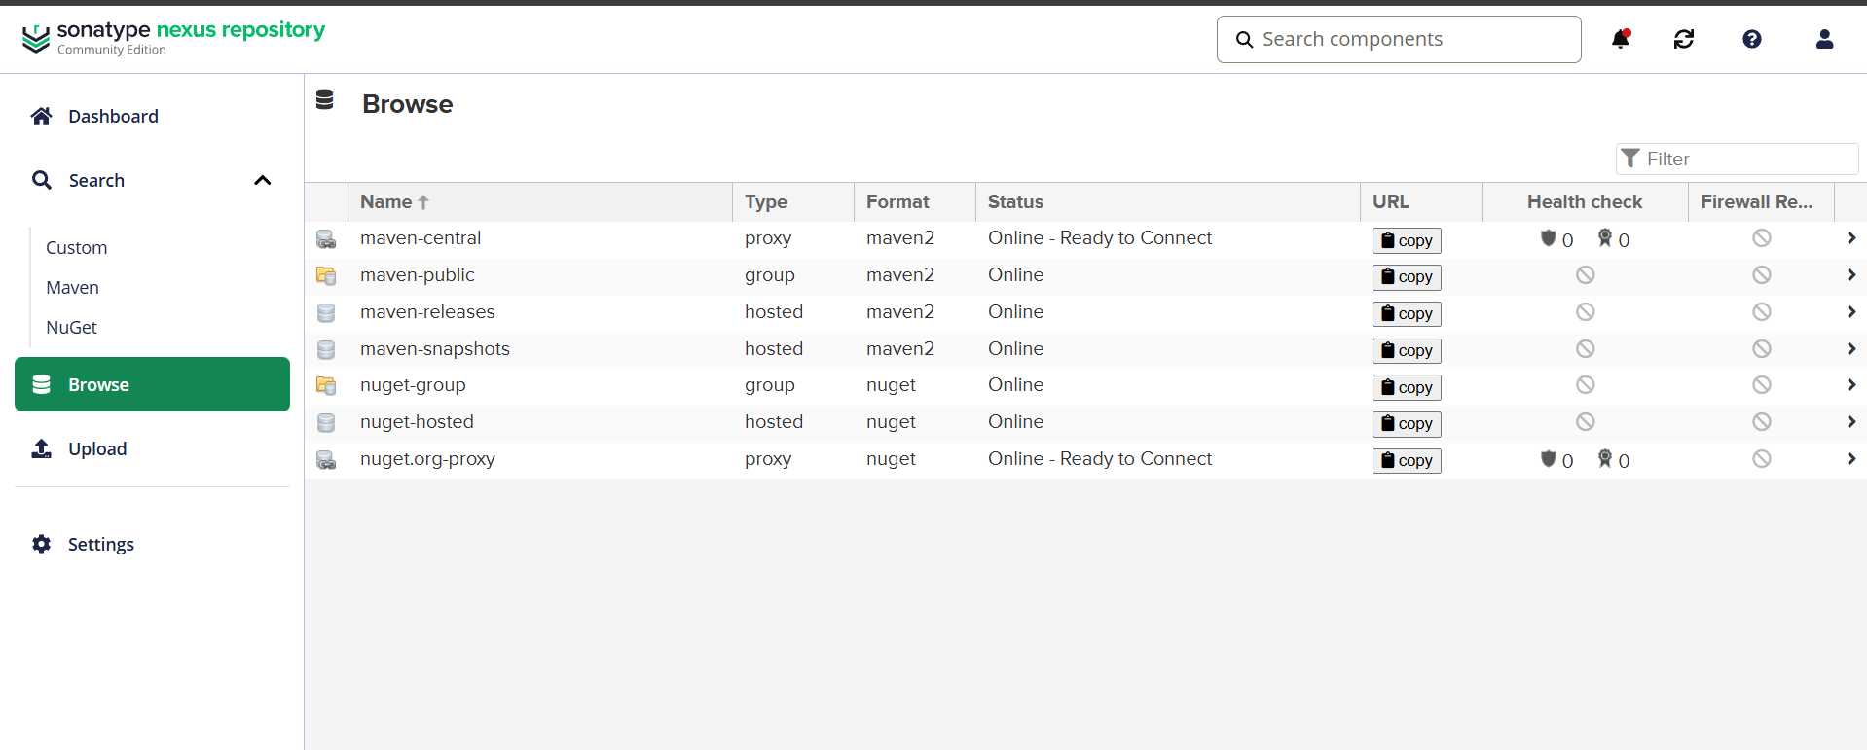
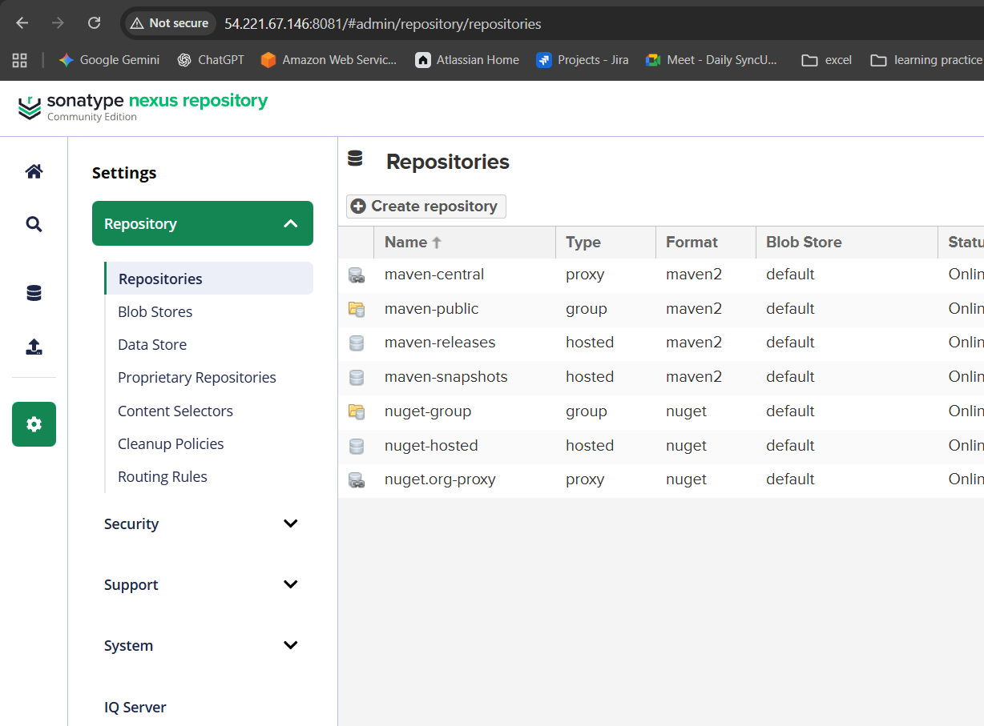
Provide a name and details as mentioned below and continue by creating it
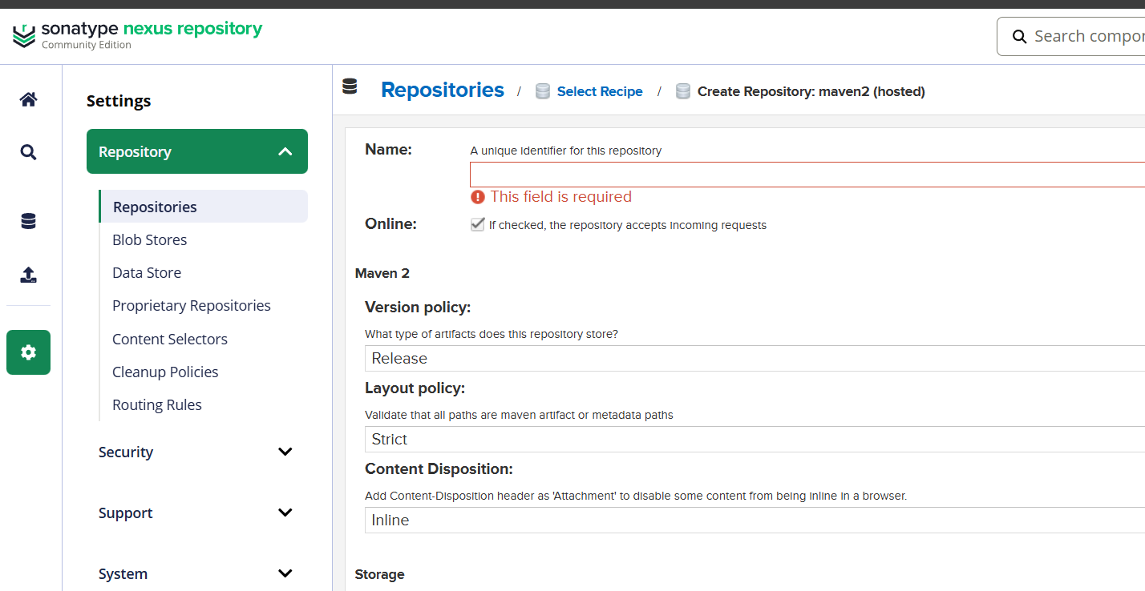
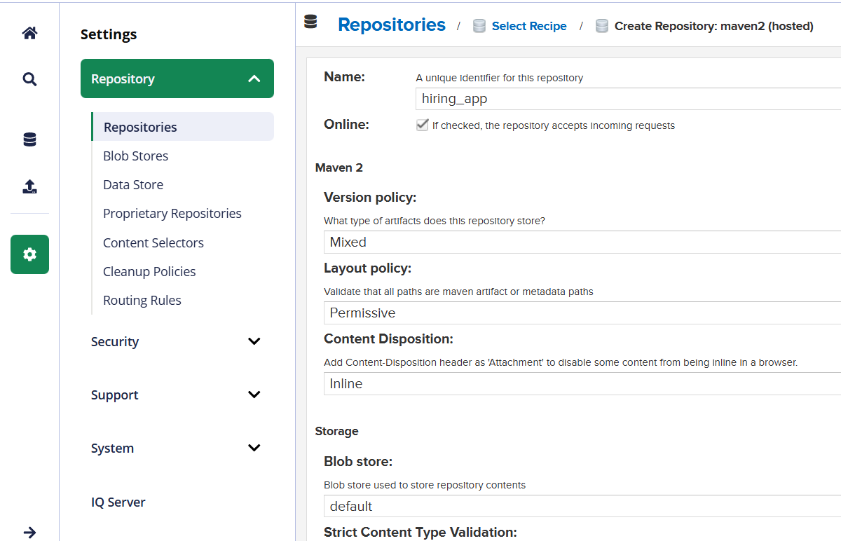

In the Deployment policy allow Redeploy
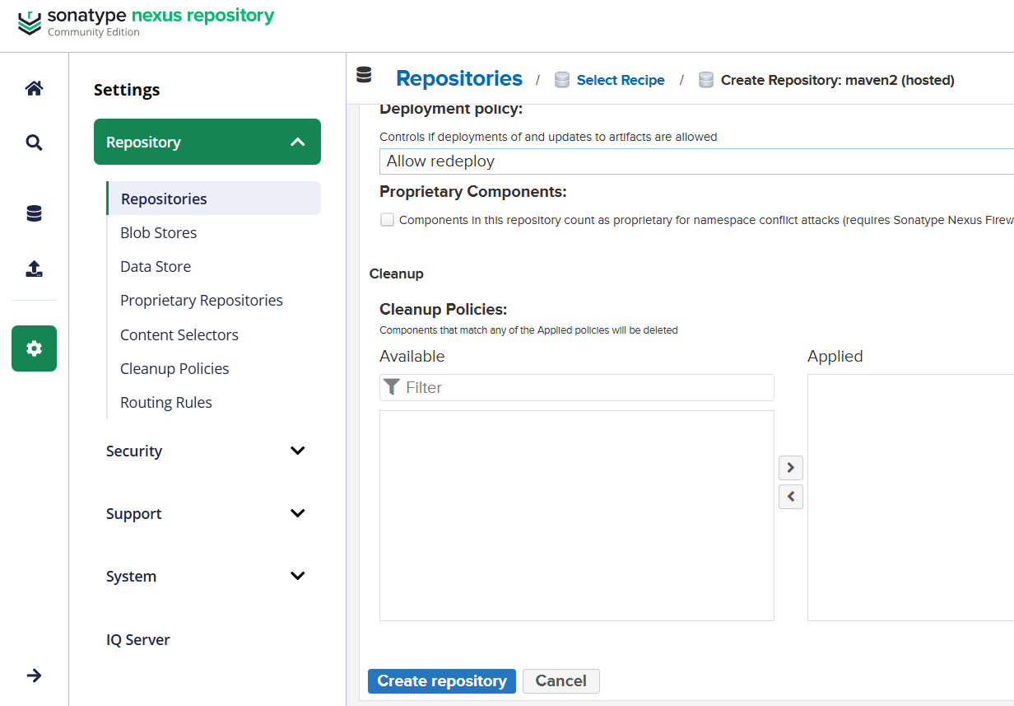
Copy the repo name and paste it over in Jenkins server
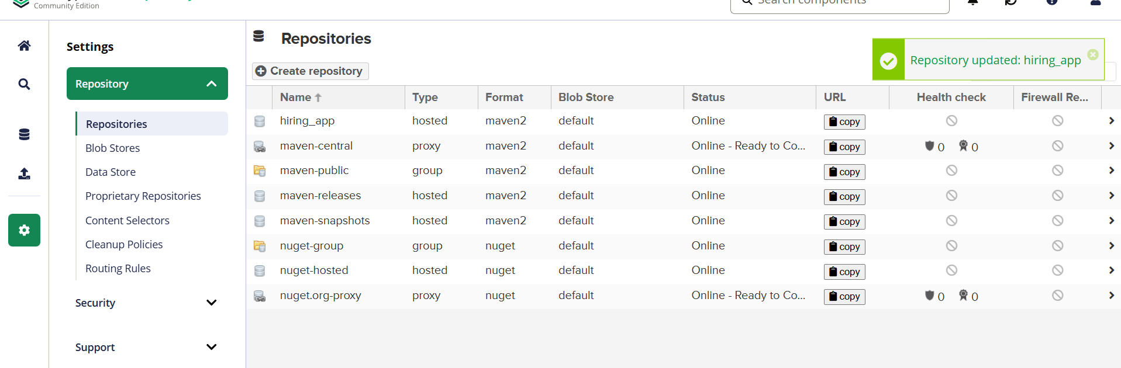
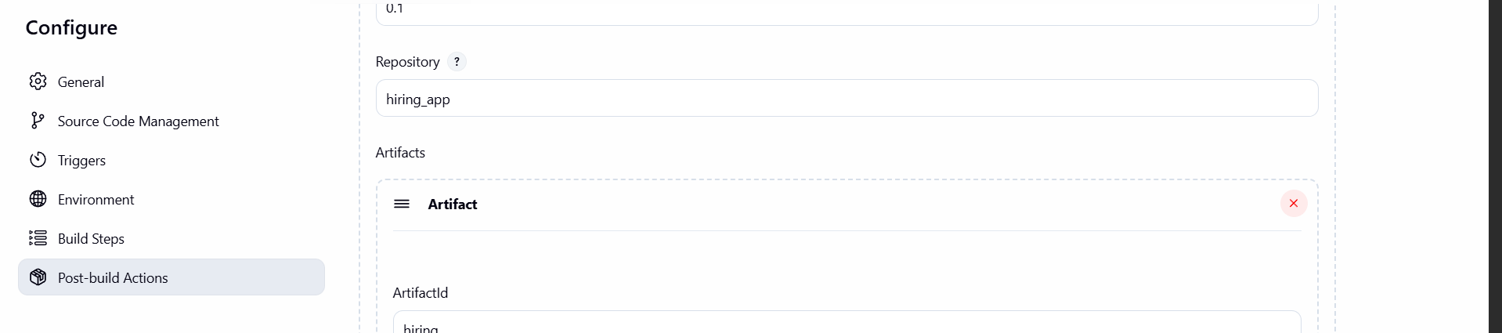

Continue with creating and in the file tab enter
Target/hiring.war
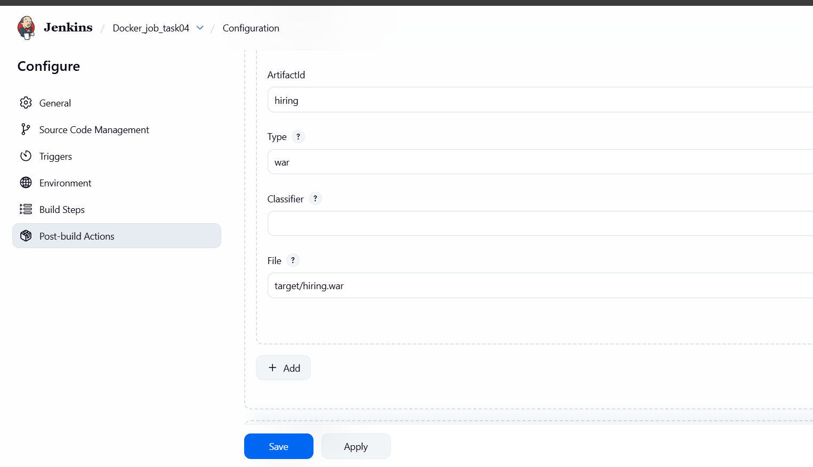
And tested using build and again faced an error
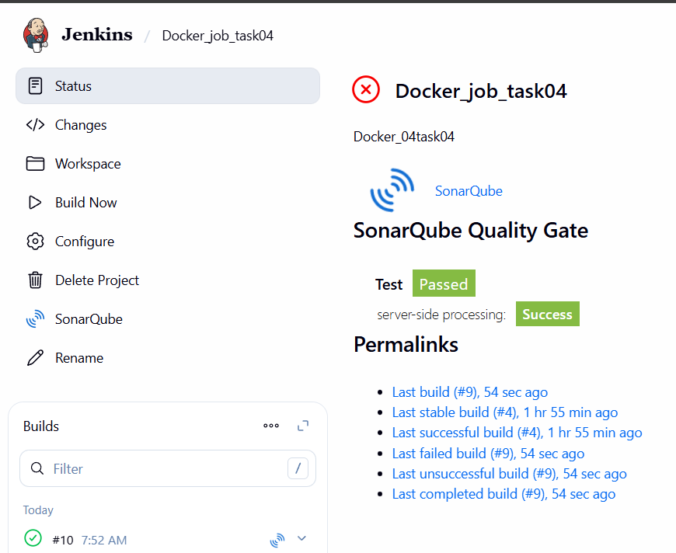

The reason is I pasted the whole url of repo instead of name so that the error had came after changing it my build was successfull
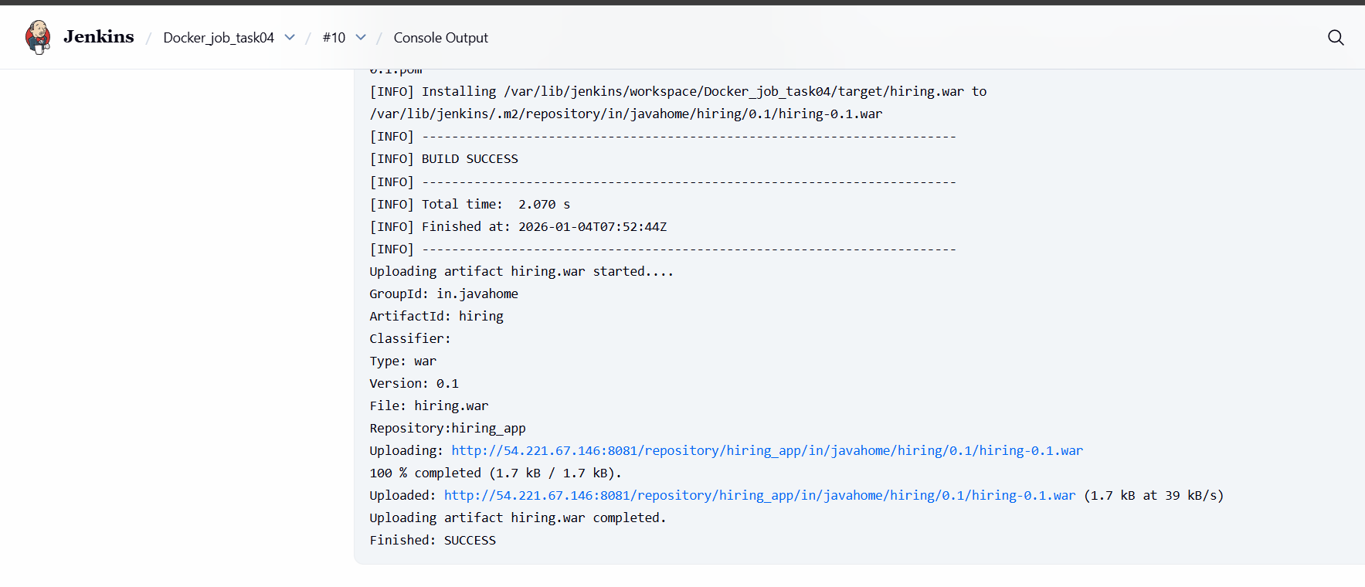
Also artifacts verified in nexus repository GUI level
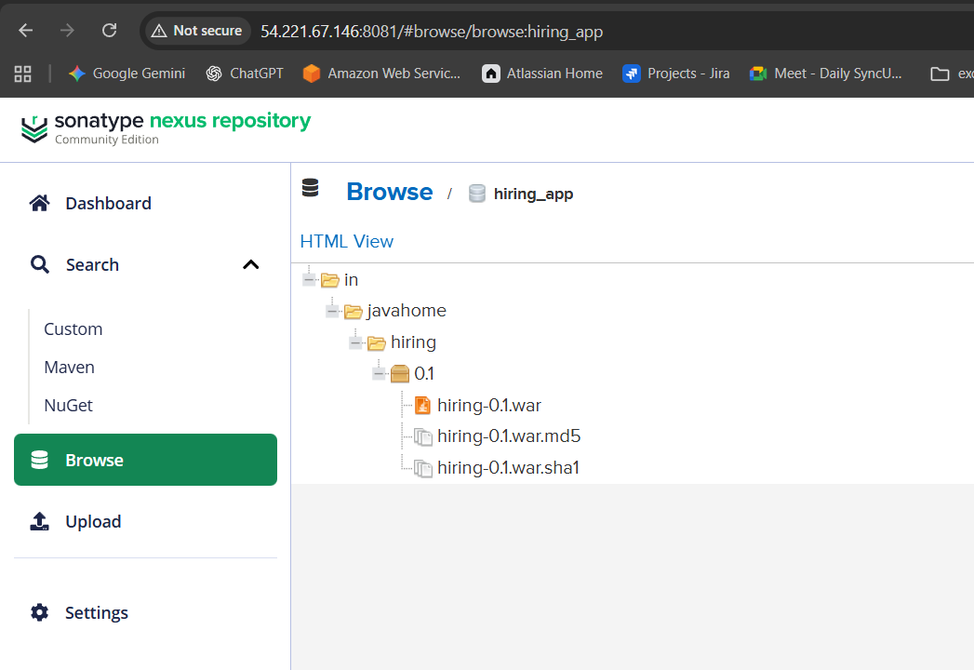

Slack Notification
Go to job select the option in slack notification and save
In my case it is configured earlier so that again integration is not required
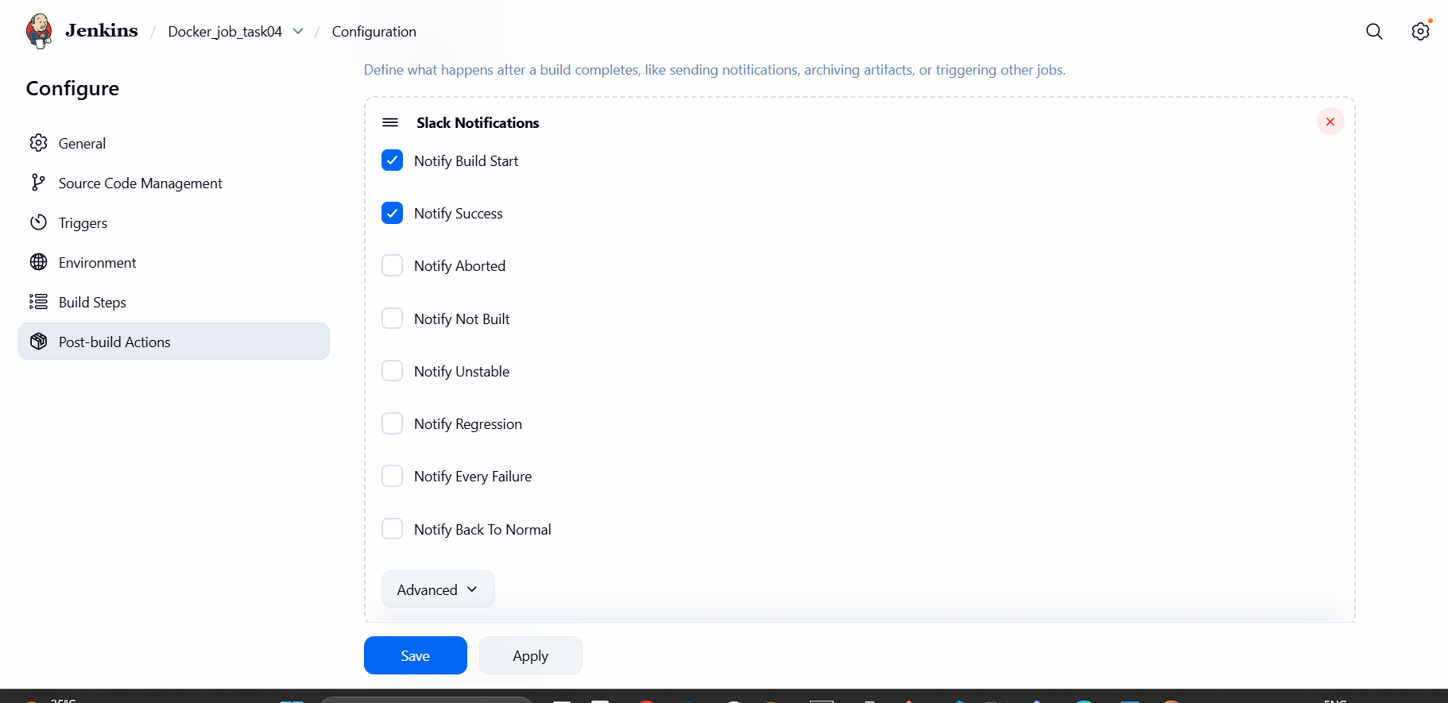
And build was successful and notified the team
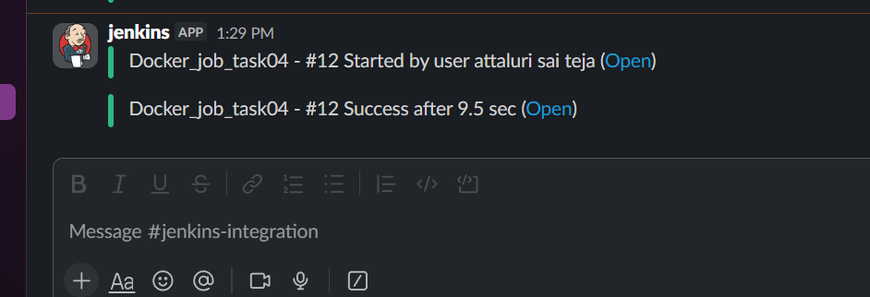

Tomcat Deployment
Launched an ec2 for installing tomcat
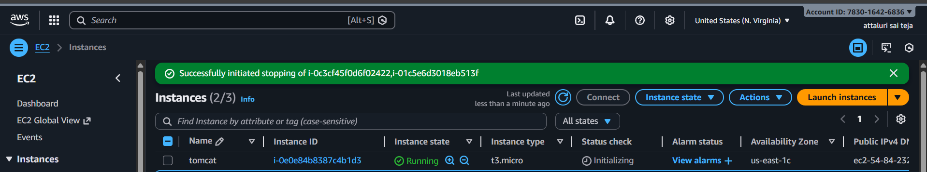
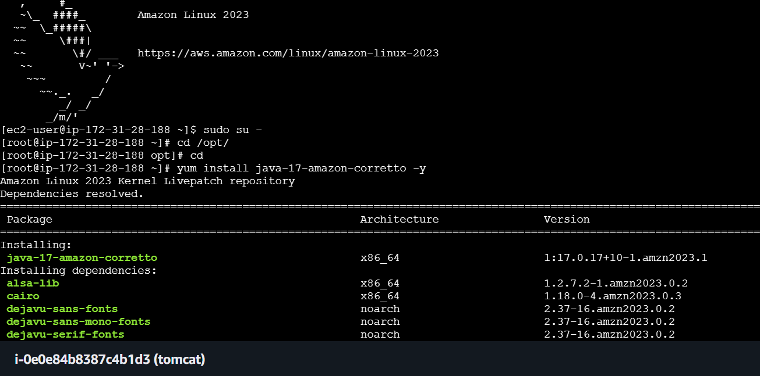
Install tomcat of version 9
With dependencies of java 17
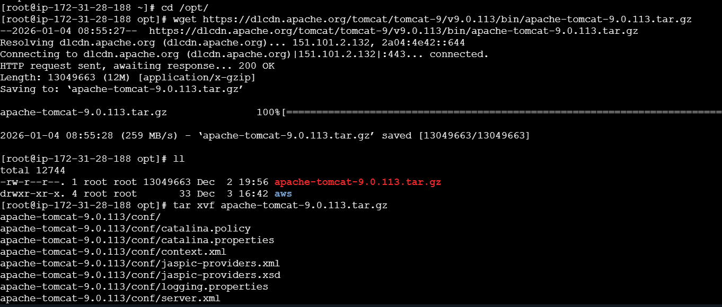
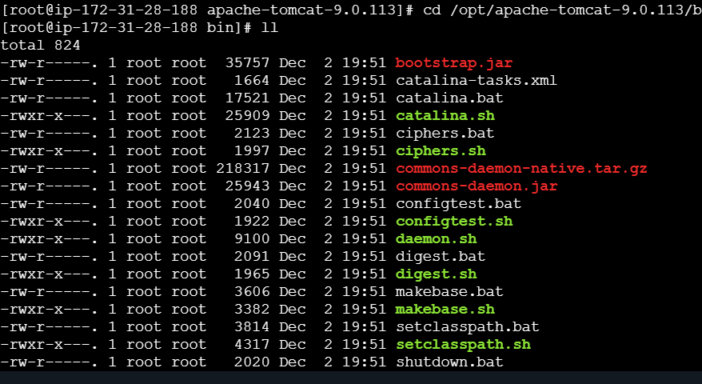
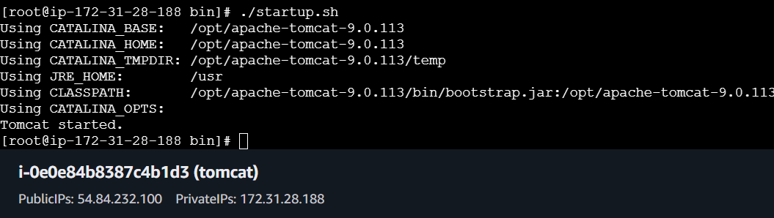
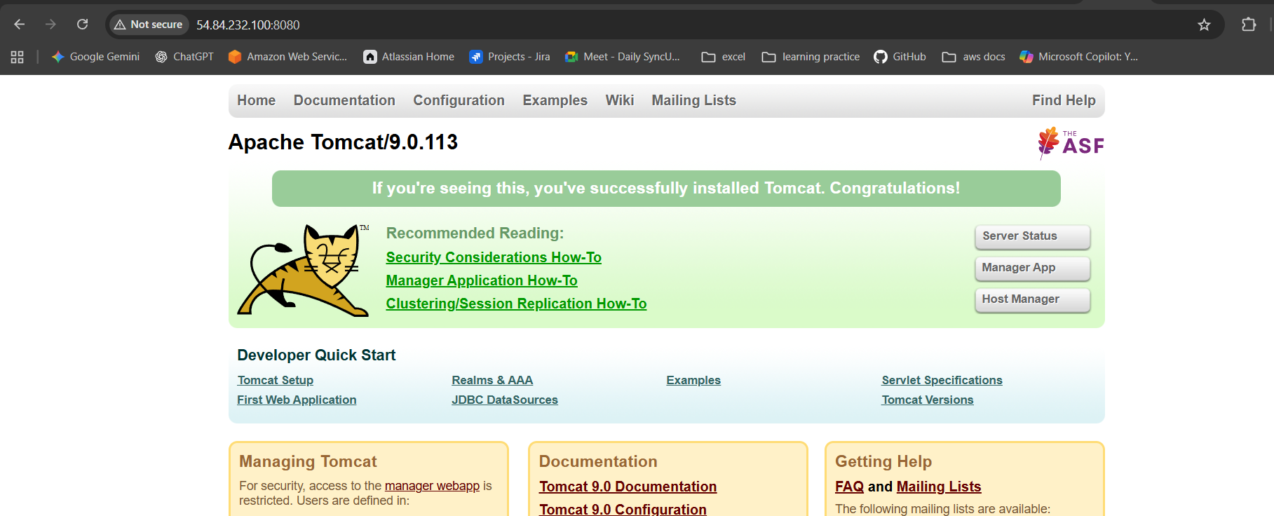

In the Jenkins we need to install a plugin called deploy to container and continue with installing it
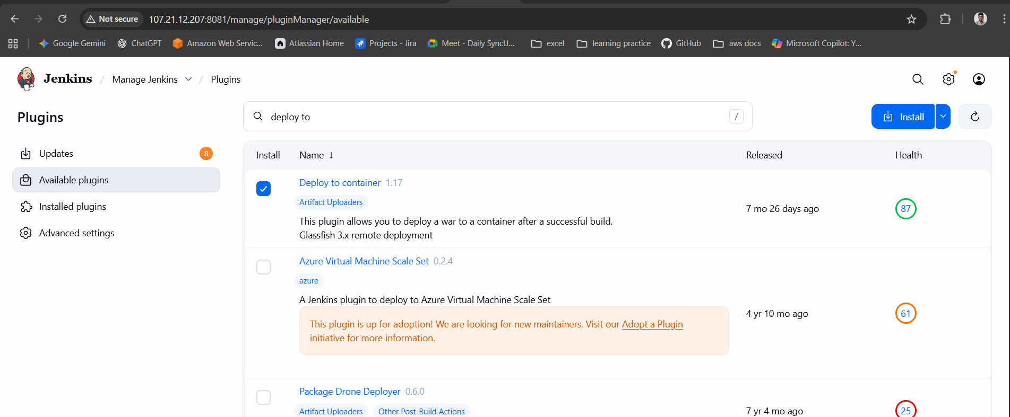
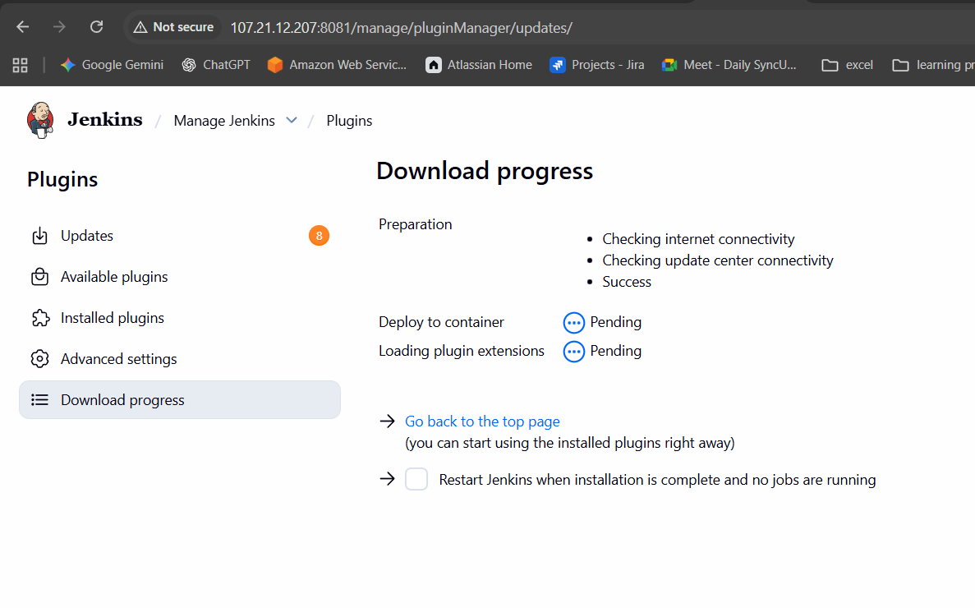

OPEN tomcat.users.xml file and paste the below commands like in image
<role rolename="manager-gui"/>
<role rolename="manager-script"/>
<user username="admin" password="admin123" roles="manager-gui,manager-script"/>
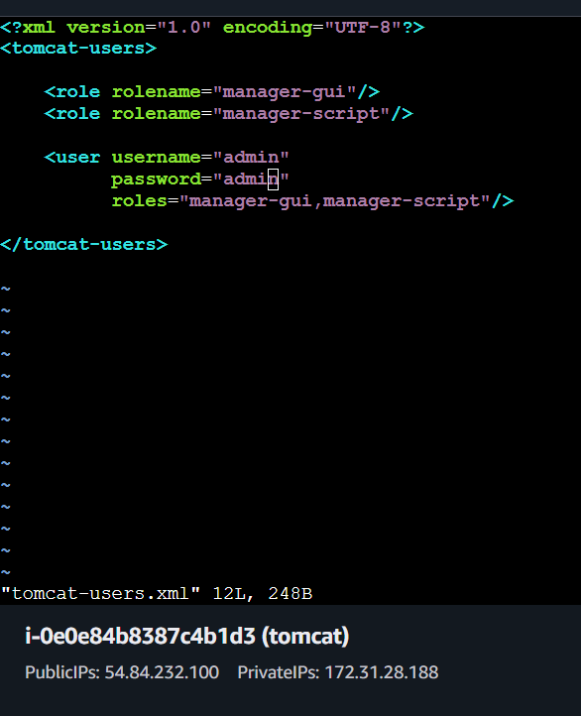

After that get back to Jenkins and I post build actions select deploy war and enter the details
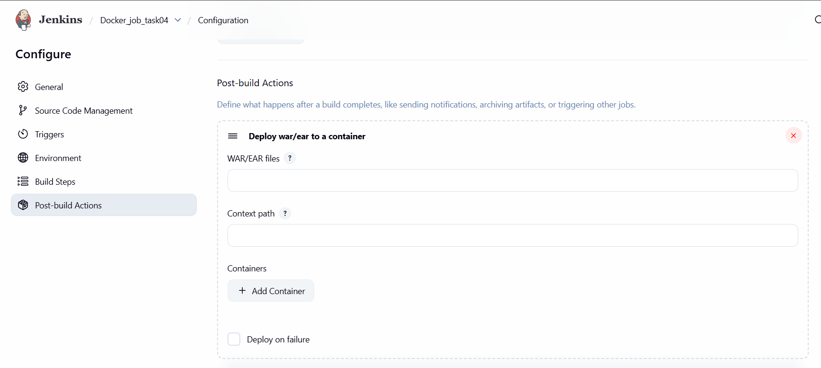
The user name should be like in users.xml like admin and admin123
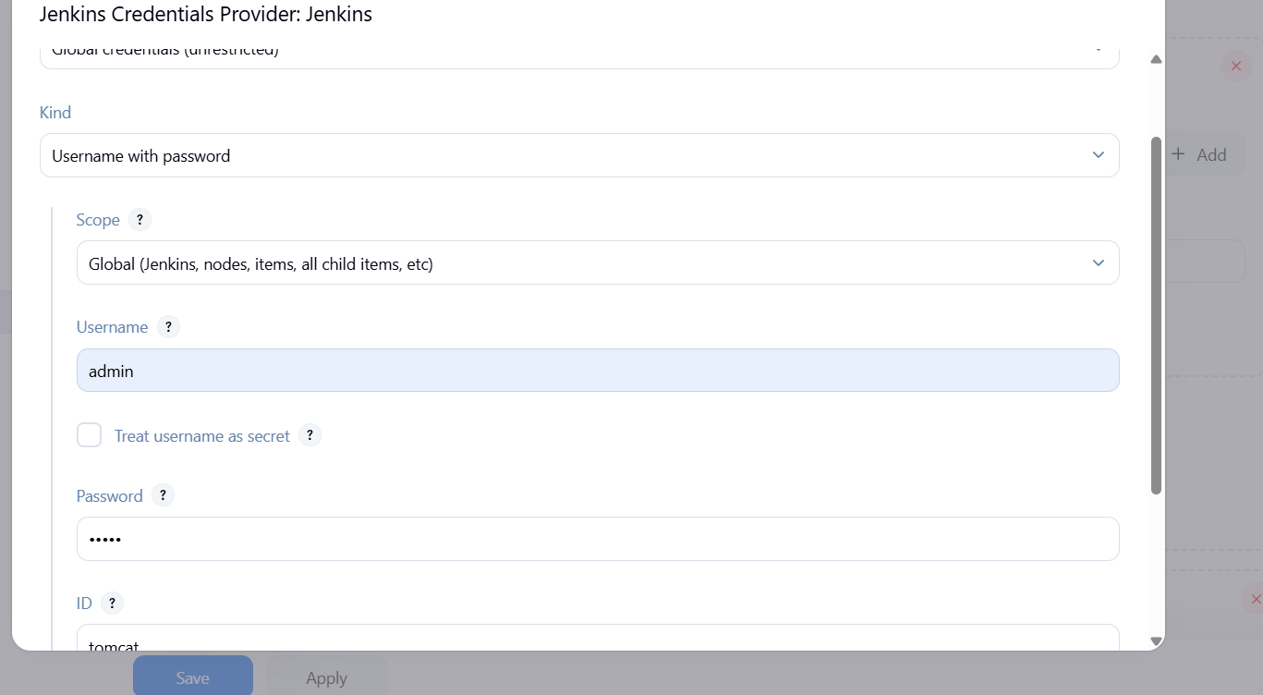
After saving it again get back to ec2 and create two file with below command and insert the data into it
sudo mkdir -p /opt/apache-tomcat-9.0.113/webapps/manager/META-INF
after that
sudo vi /opt/apache-tomcat-9.0.113/webapps/manager/META-INF/context.xml
insert the data
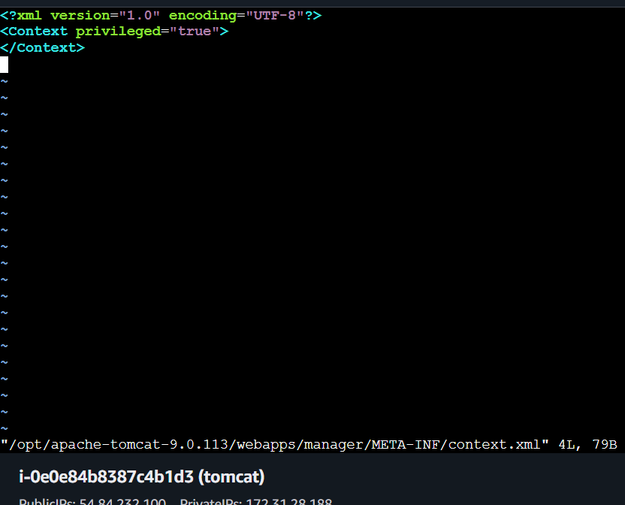
For second file”::
sudo mkdir -p /opt/apache-tomcat-9.0.113/webapps/host-manager/META-INF
sudo vi /opt/apache-tomcat-9.0.113/webapps/host-manager/META-INF
insert the data
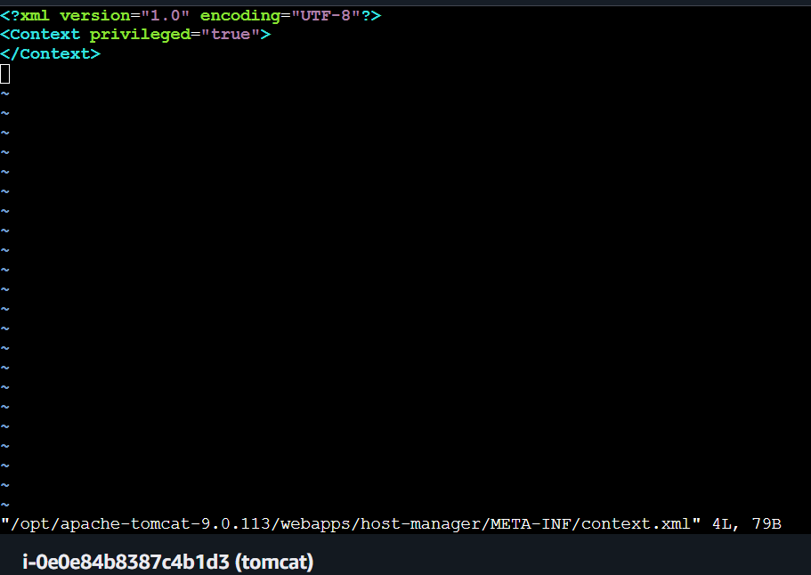
Security Manager may be enabled via JVM option.
Search for it:
grep -n "java.security.manager" /opt/apache-tomcat-9.0.113/bin/catalina.sh
The add comment # before it
Commands do the same for other
vi +394 /opt/apache-tomcat-9.0.113/bin/catalina.sh
vi +423 /opt/apache-tomcat-9.0.113/bin/catalina.sh
vi +504 /opt/apache-tomcat-9.0.113/bin/catalina.sh
after executing the output will be
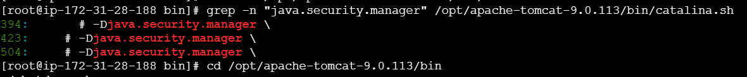

Edit context.xml
vi /opt/apache-tomcat-9.0.113/webapps/host-manager/META-INF/context.xml
Paste EXACTLY this:
<?xml version="1.0" encoding="UTF-8"?>
<Context privileged="true">
</Context>
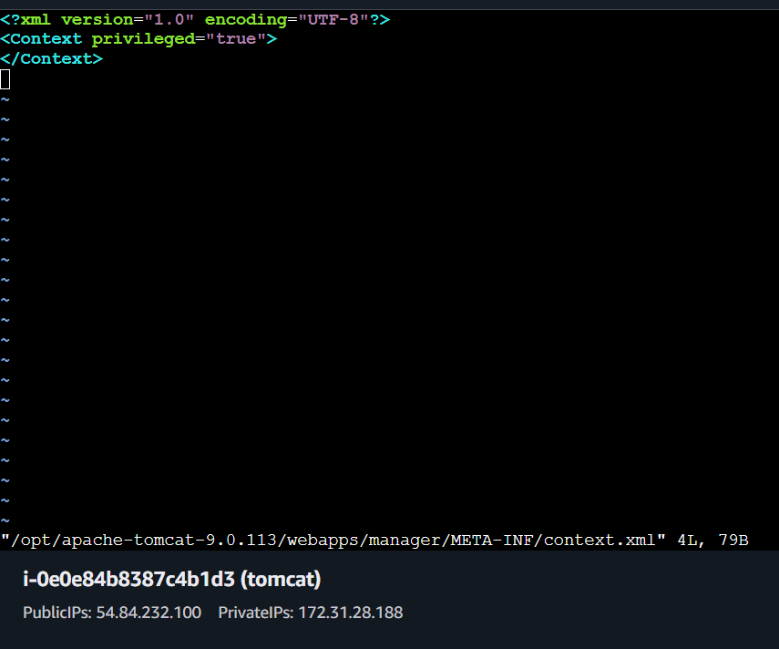

After that restart the tomcat and verify
Enter the details of user and continue
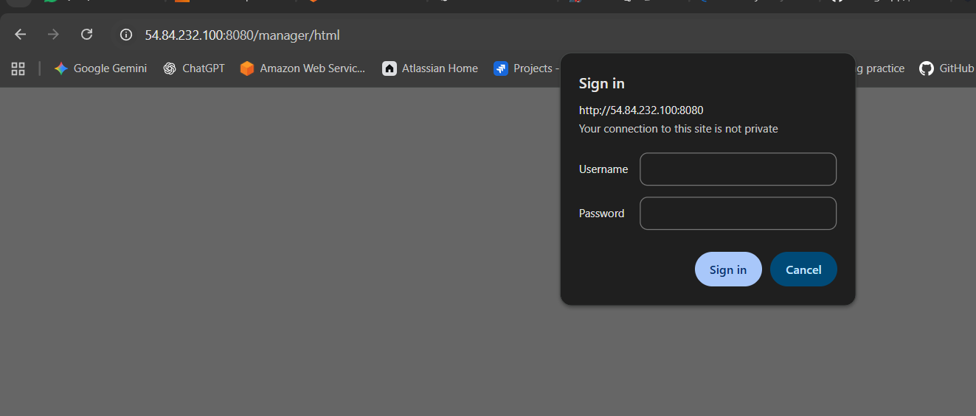
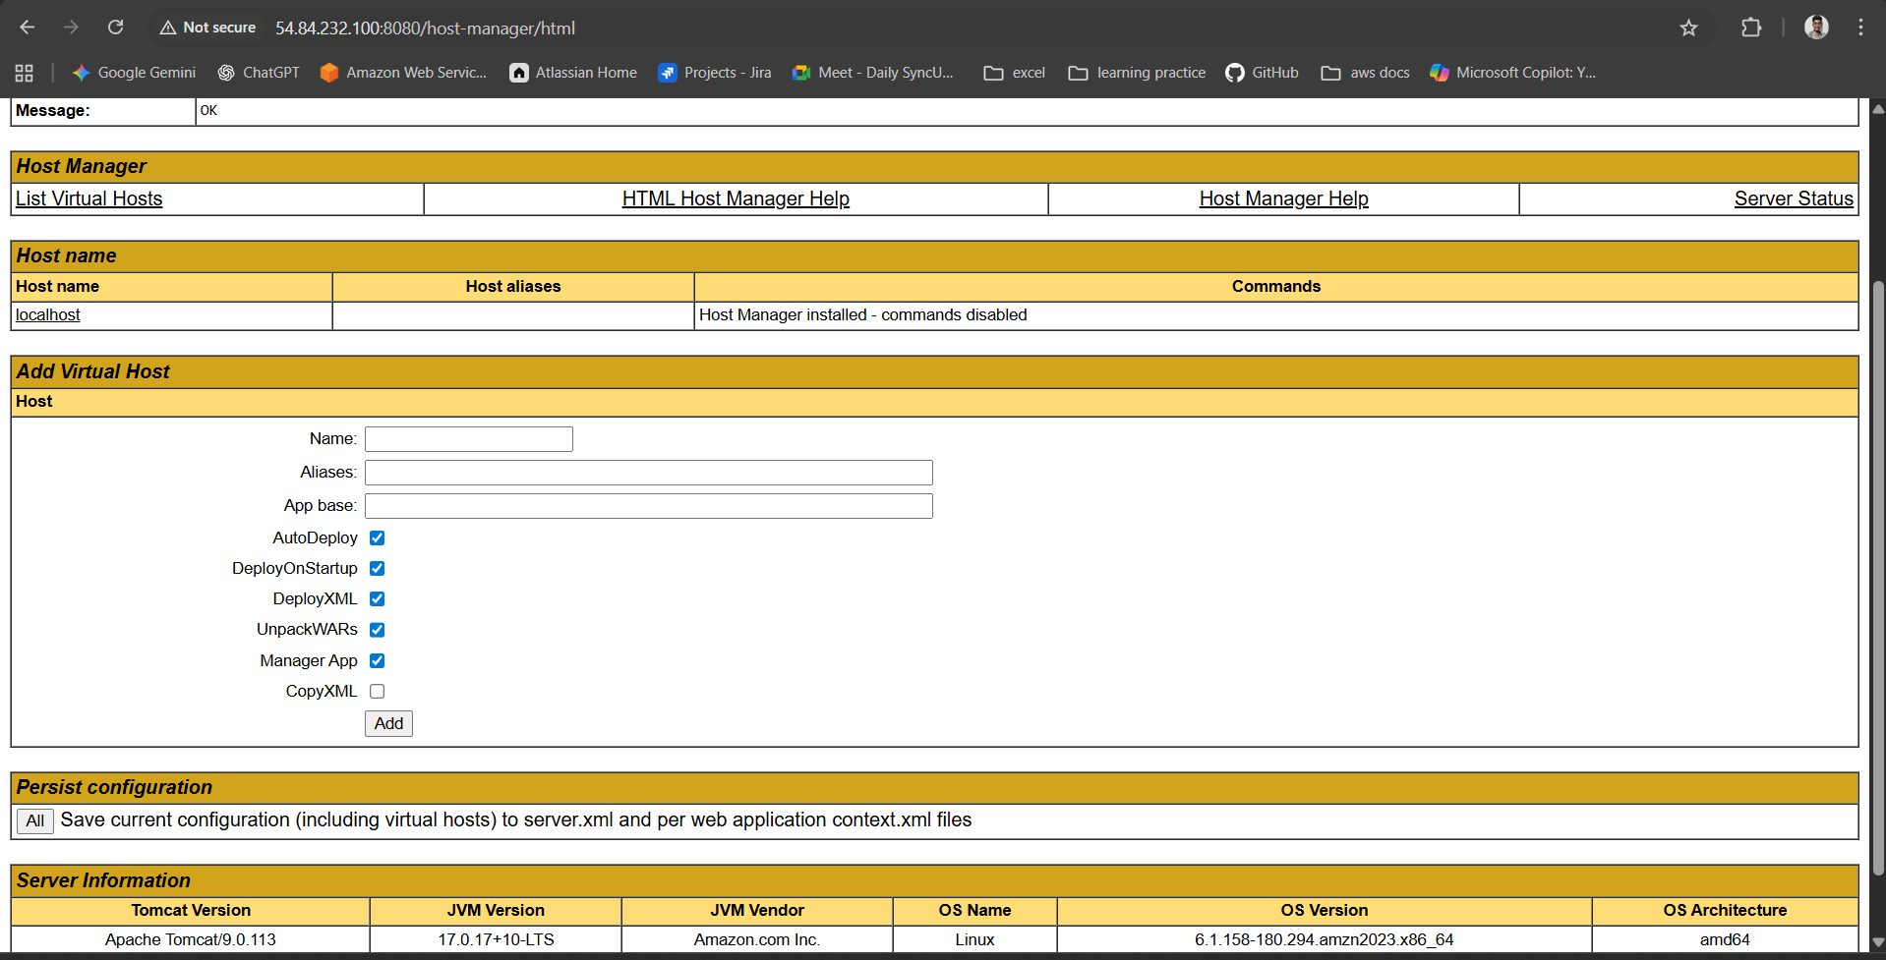
Also build was successful
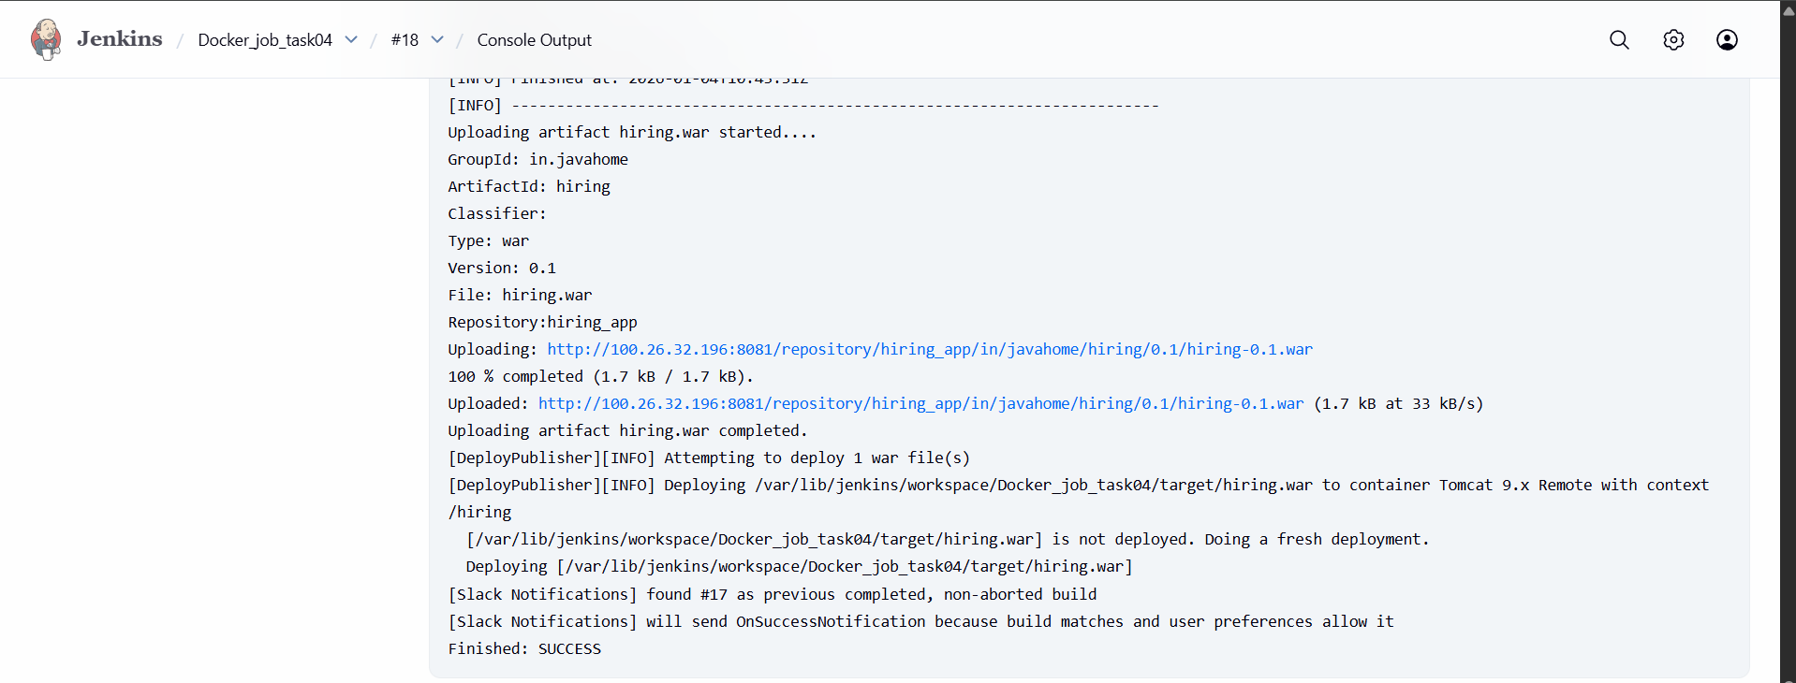
In slack also notified
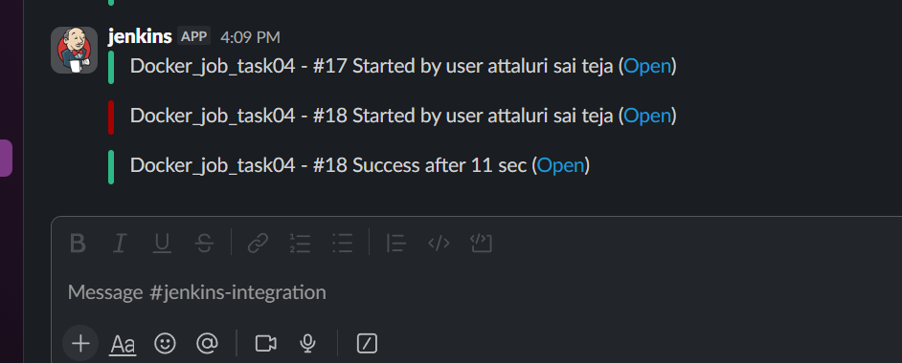
When deploying a WAR from Jenkins to Tomcat, Tomcat enforces multiple layers of security.
Your deployment initially failed because each layer blocked the request in a different way.
We had to align Tomcat’s security model with automated CI/CD deployment.
What we changed
- Added roles:
  - manager-script (mandatory for Jenkins)
  - manager-gui (optional, for browser access)
  - admin-gui, admin-script (for host-manager UI)
- Created a deployment user (admin)
Why this was required
- Jenkins uses Tomcat Manager APIs (/manager/text)
- Without manager-script, Tomcat rejects deployment commands
- Browser UI and Jenkins use different roles
📌 Key point
Jenkins does NOT use manager-gui; it requires manager-script.

Final Architecture After Fix
Jenkins
|
| (HTTP + manager-script)
v
Tomcat ManagerServlet (privileged)
|
v
Deploy hiring.war
“Tomcat blocks automated deployments by default using role-based access, IP filtering, servlet privilege checks, and Java Security Manager. To enable Jenkins deployment, we configured manager-script roles, marked Manager applications as privileged, and disabled the Java Security Manager, which otherwise prevents Container Servlet execution.”

